**SDLC, Agile and Software Testing**

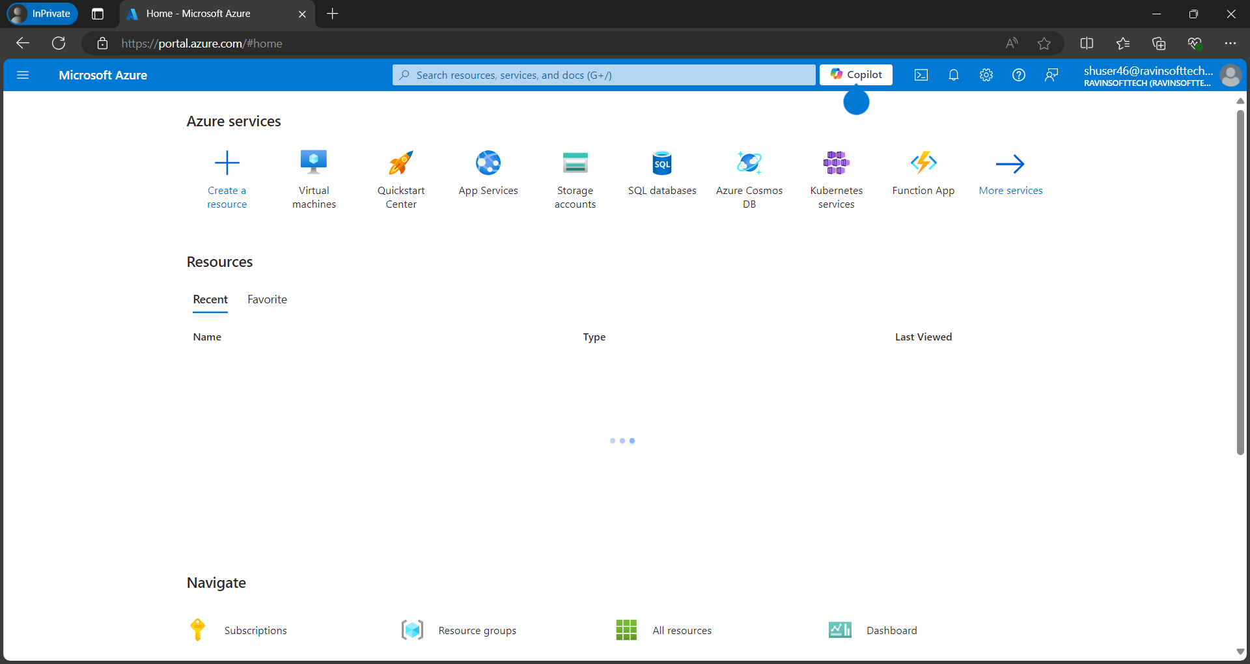

1. Open <https://portal.azure.com/> and login

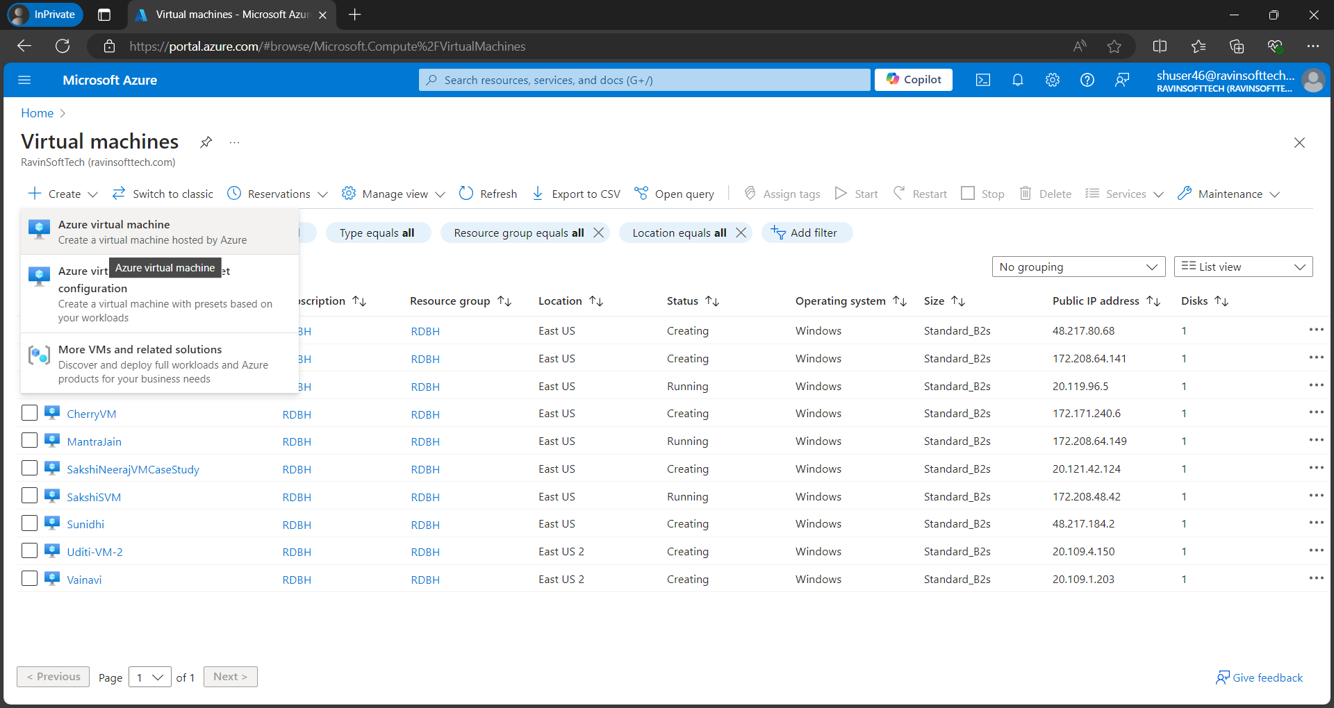

1. Create new VM.

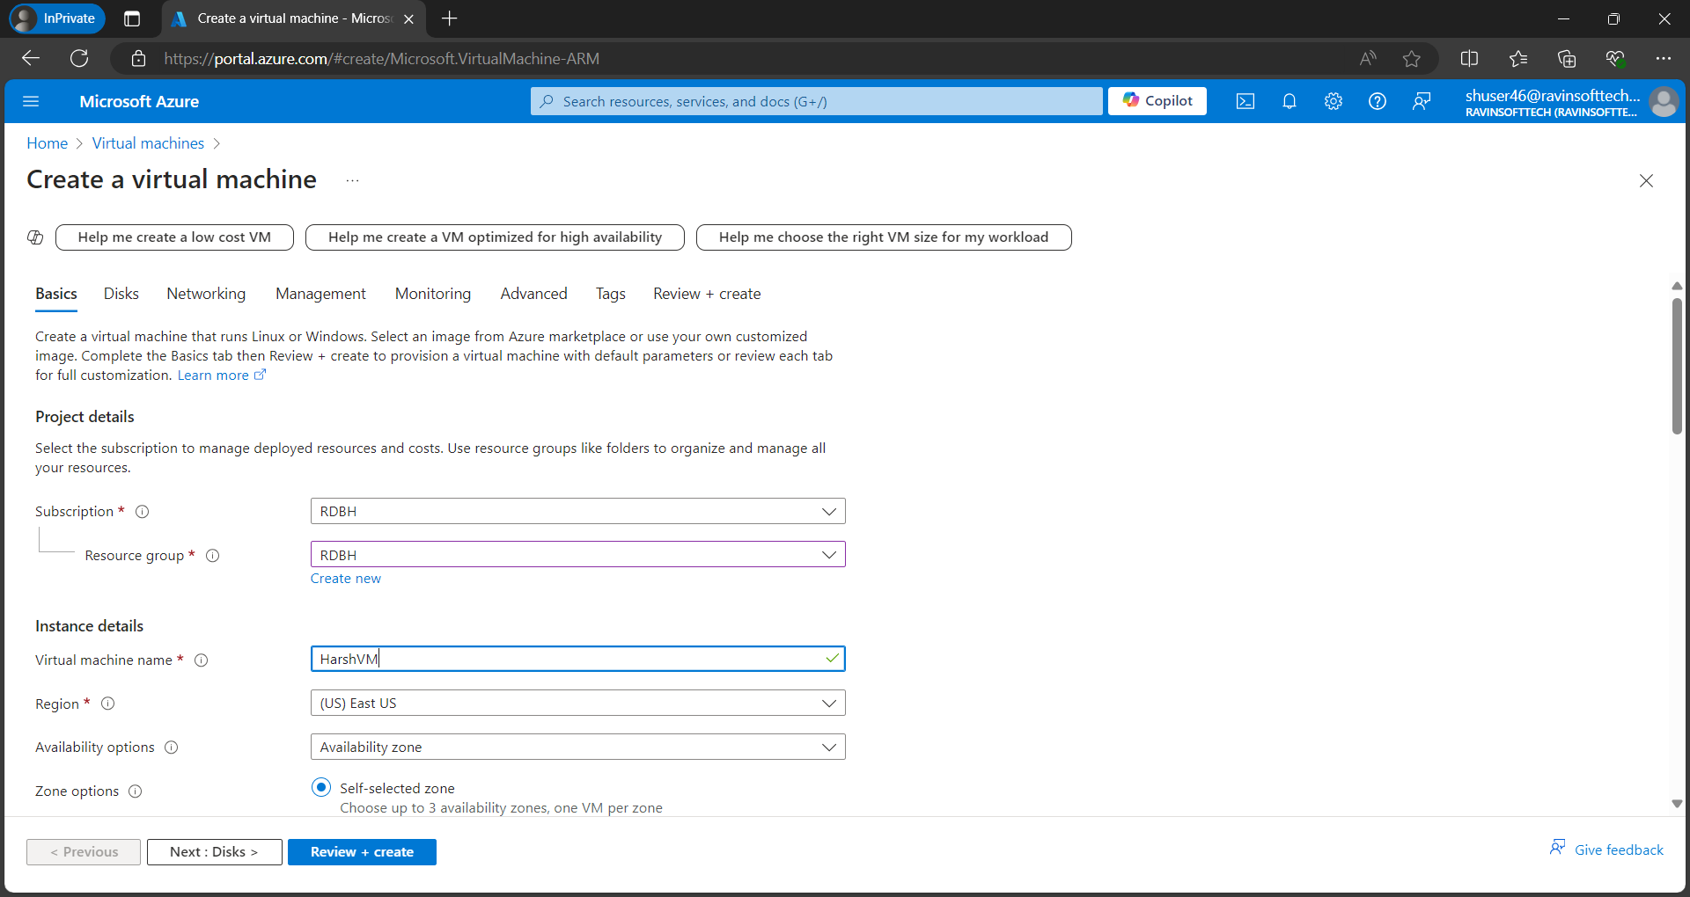

1. In resource group change it to “RDBH”.
2. Then add VM name
3. Change region

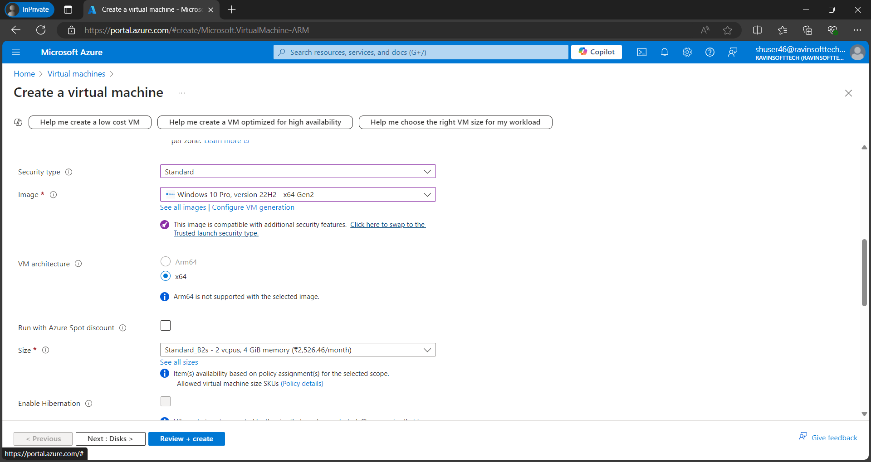

1. Then change Image to “Window 10 pro, version 22H2 – 64x Gen2”
2. Then change the size to standard.

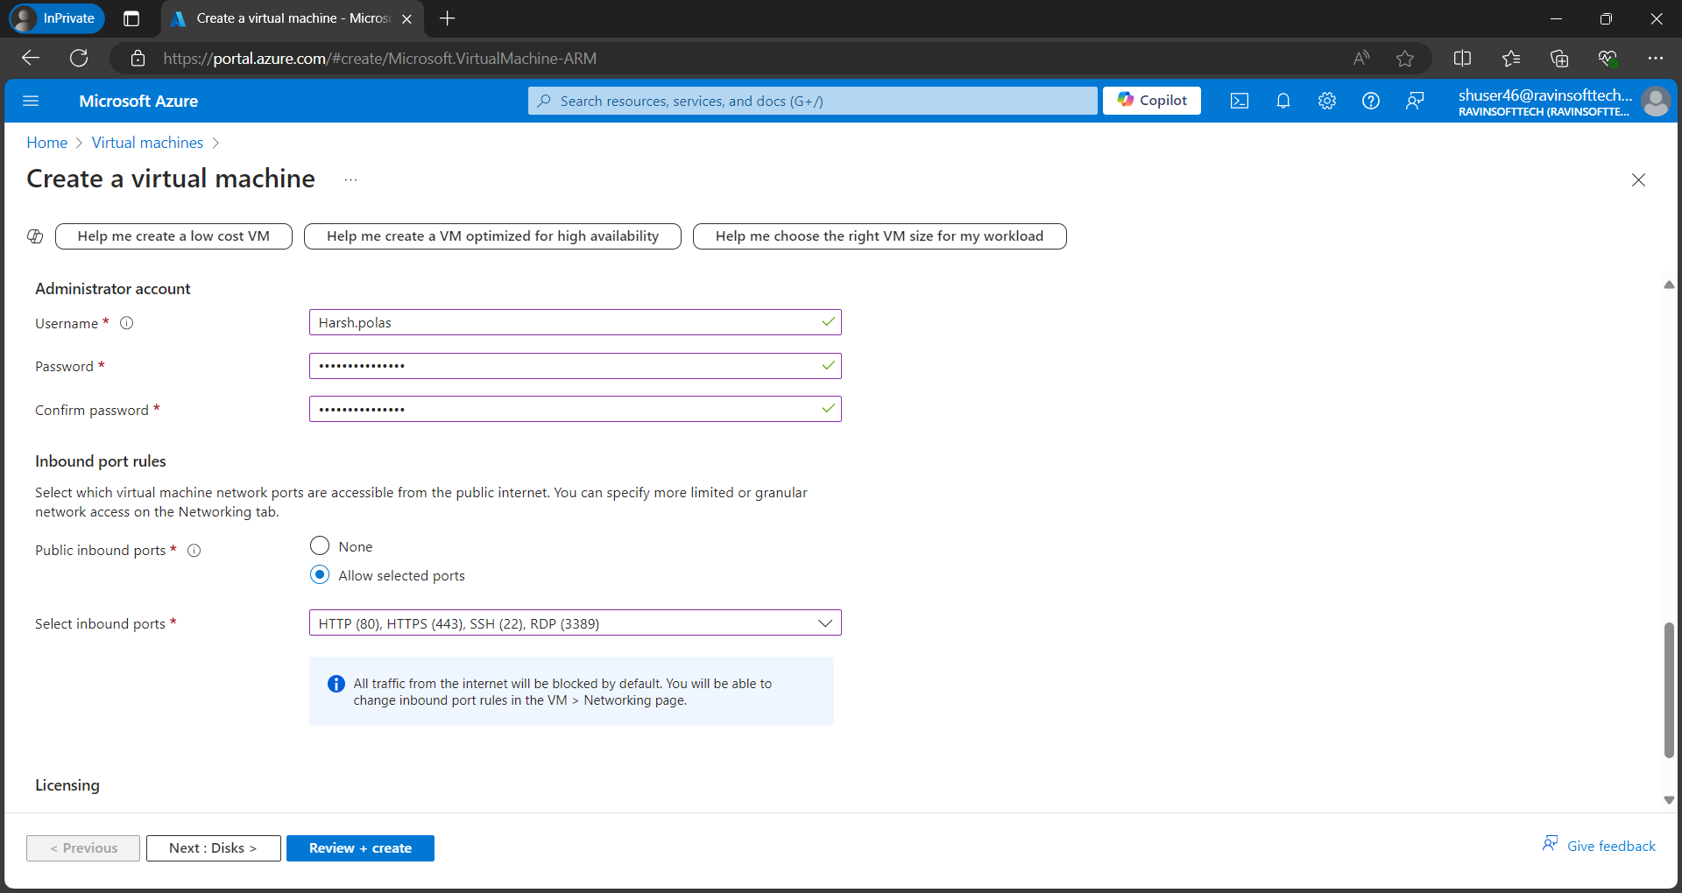

1. Update the changes in administrator account.

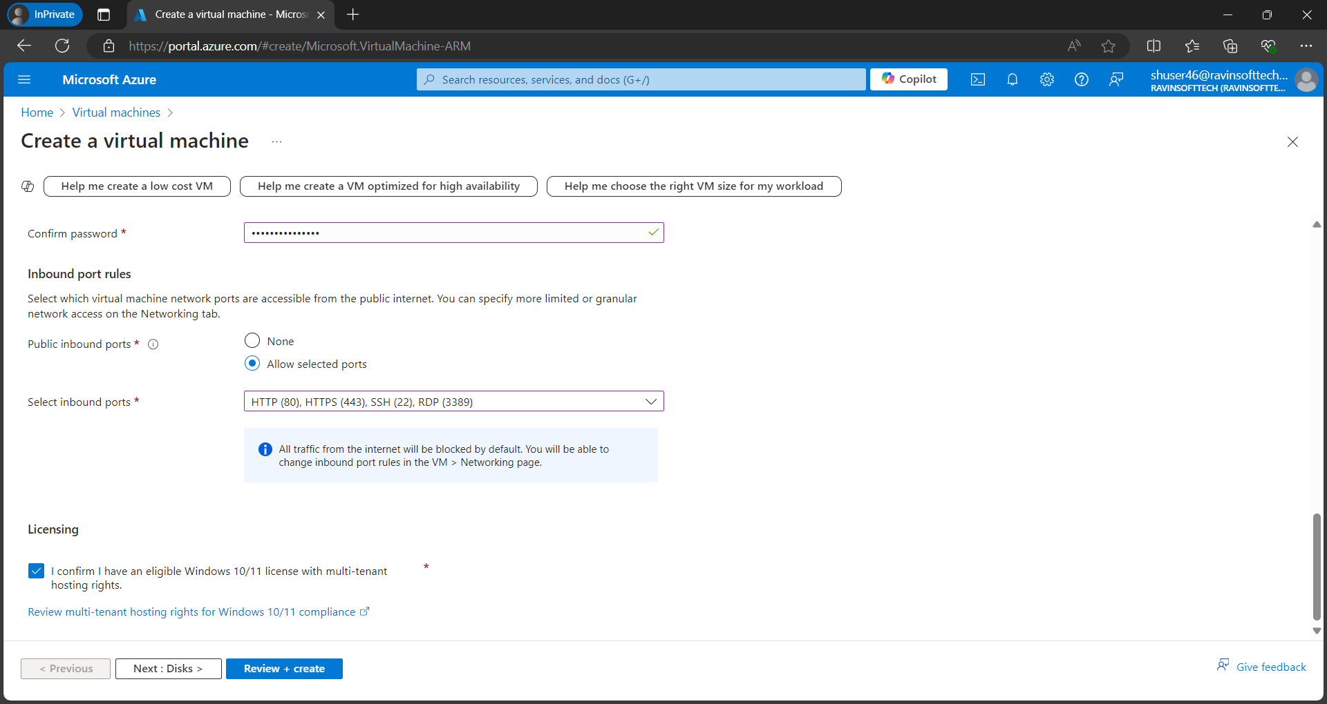

1. Select all HTTP, HTTPS, SSH, RDP, then select I confirm and select next.

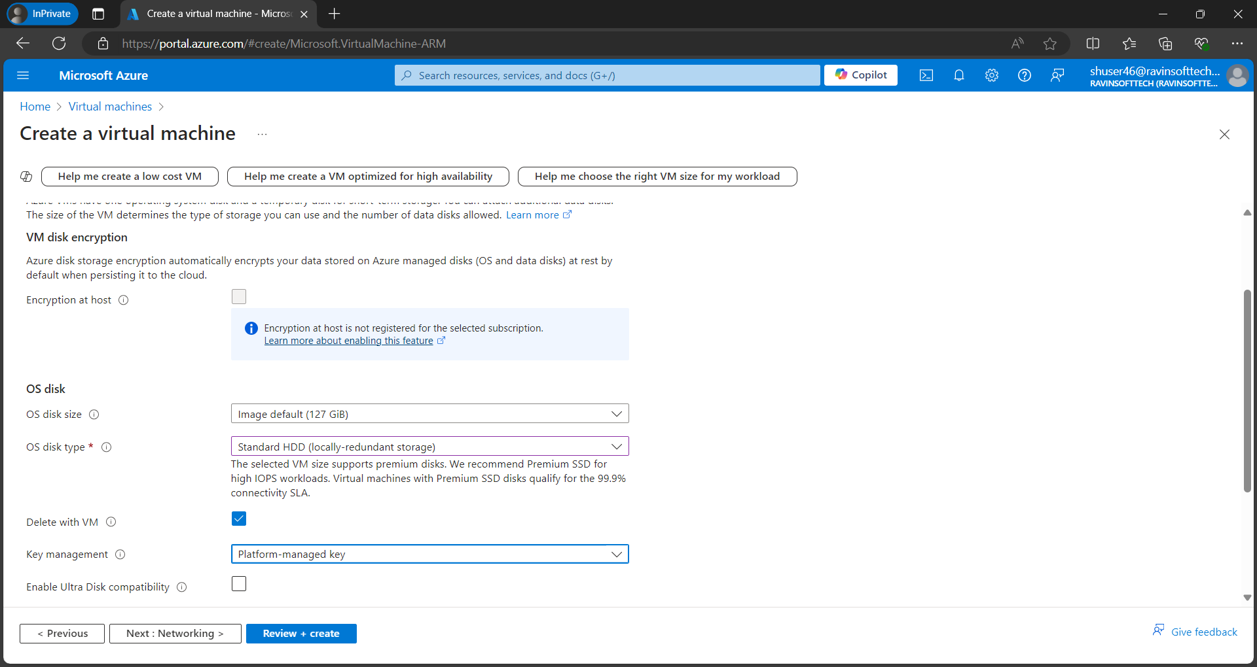

1. Then make changes to standard.

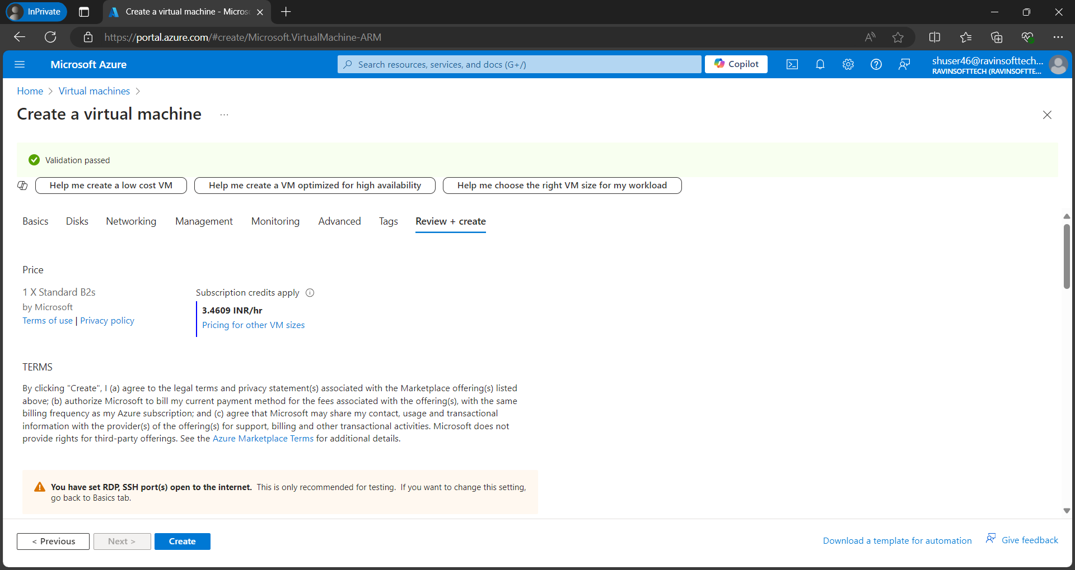

1. Then finally create and run the VM.

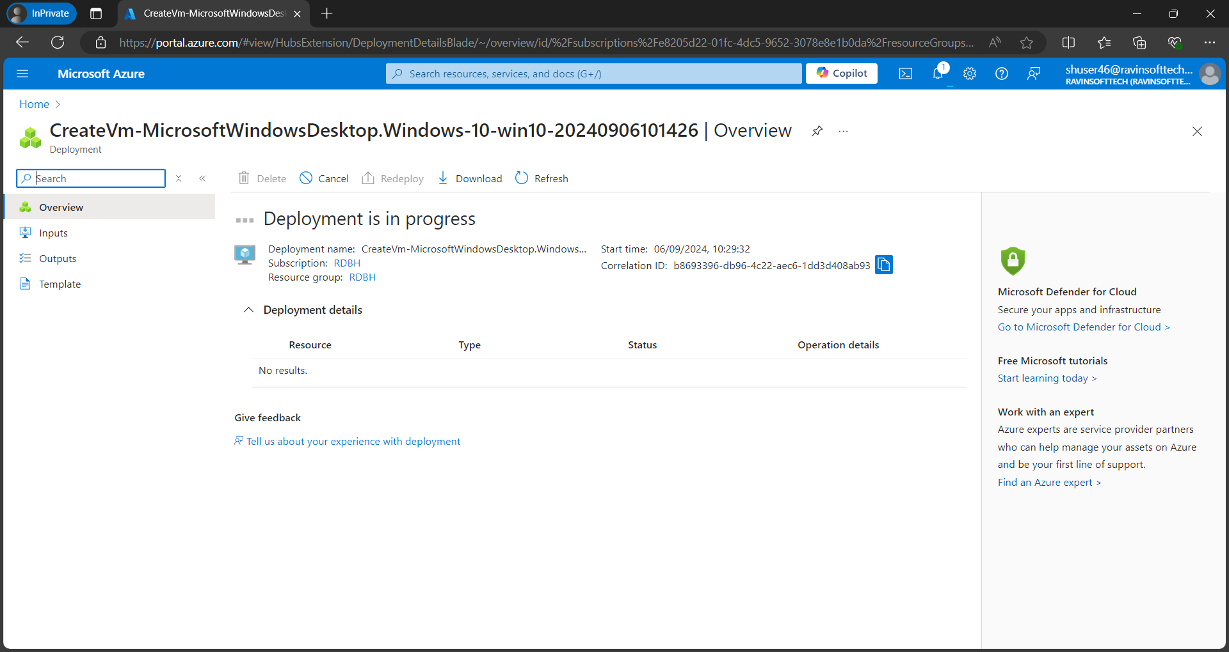

1. Wait for deployment.

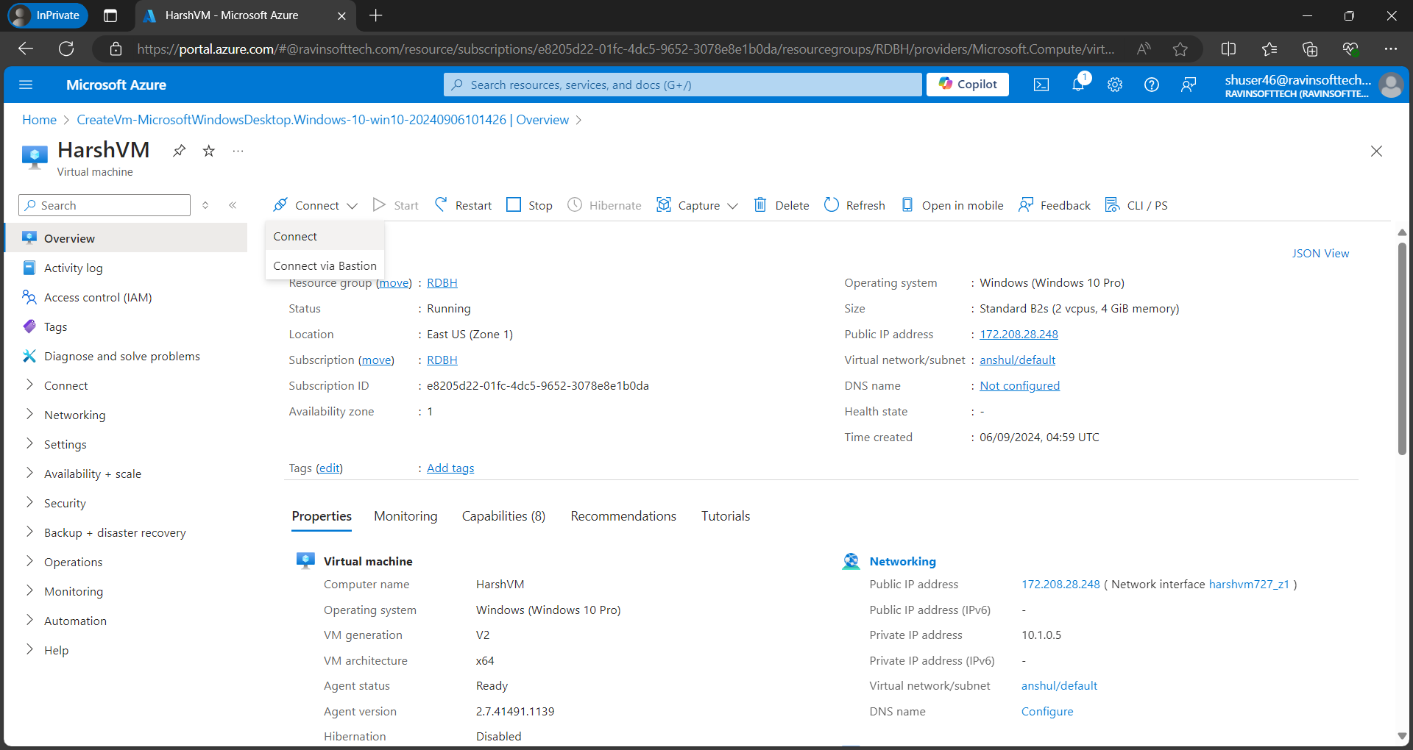

1. when deployed select connect.

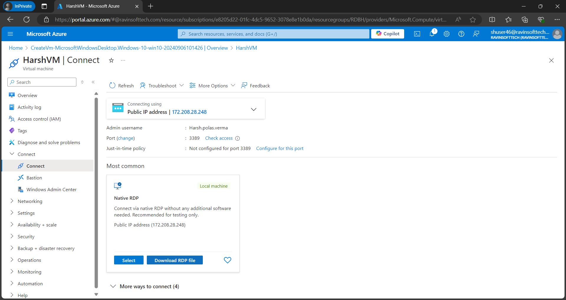

1. Then download the RDP file to run VM.

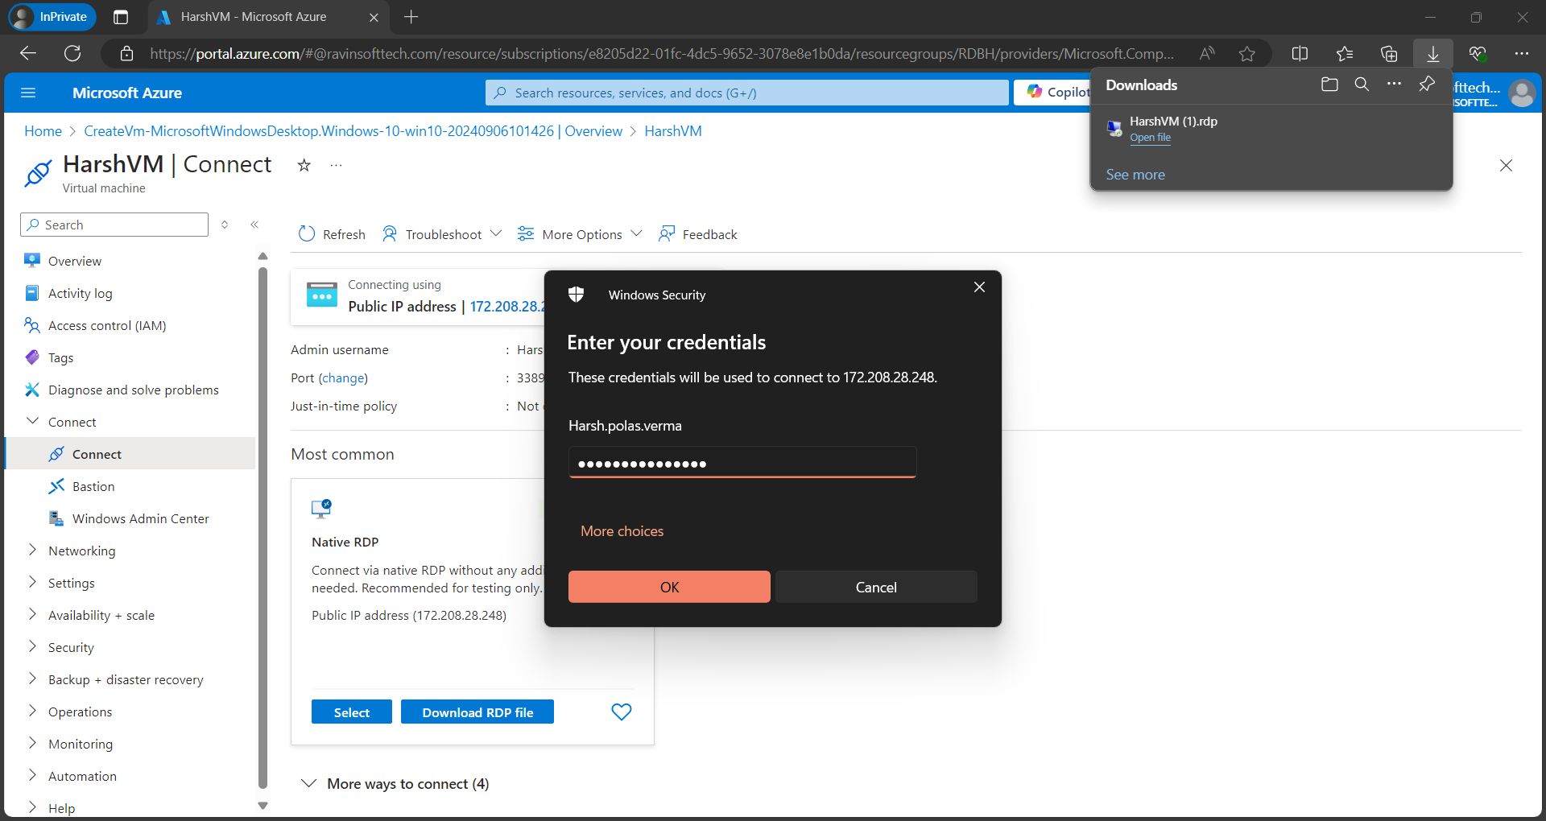

1. Now enter the password.

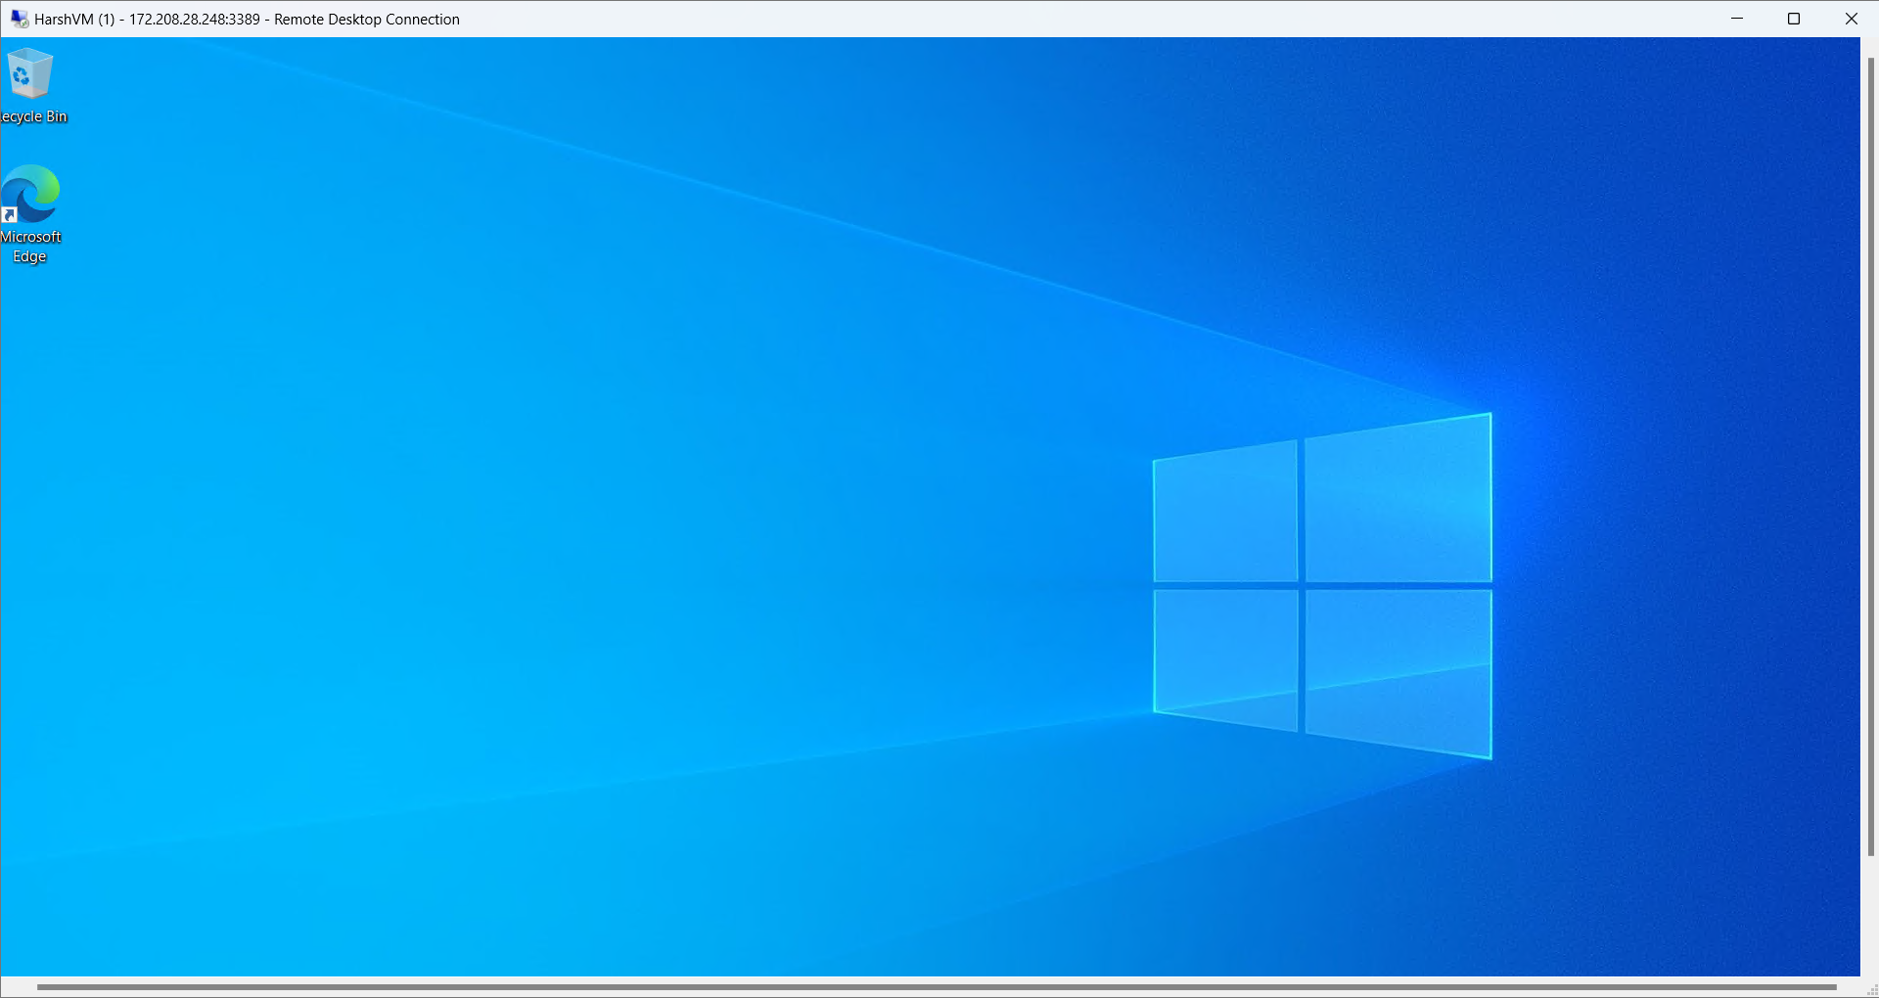

1. Successfully opened VM

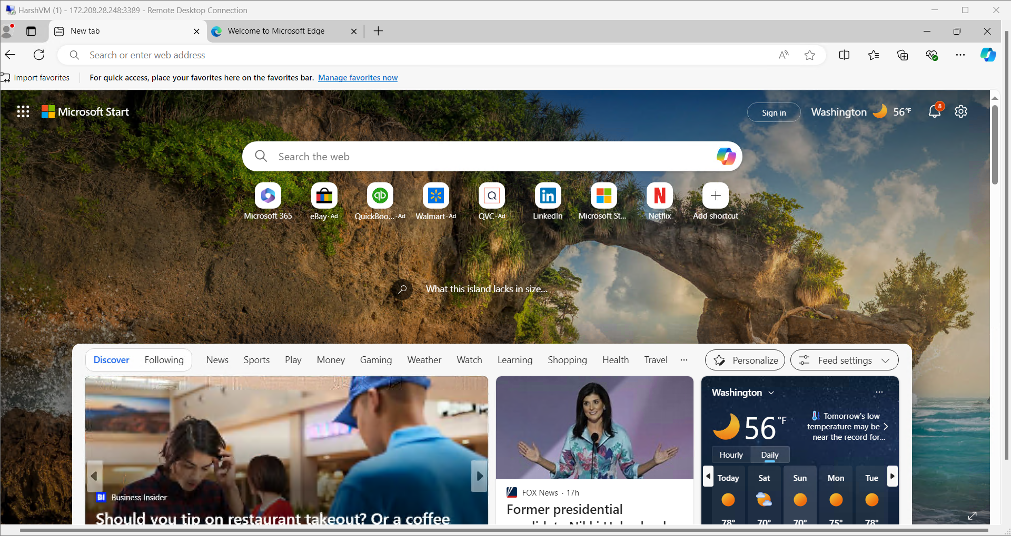

1. Now open edge and search Azure DEVOPs

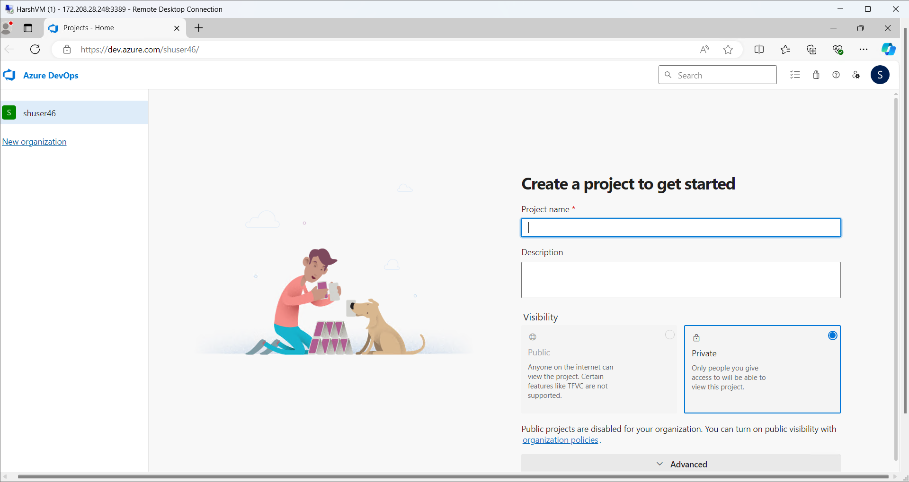

1. Now create new project.

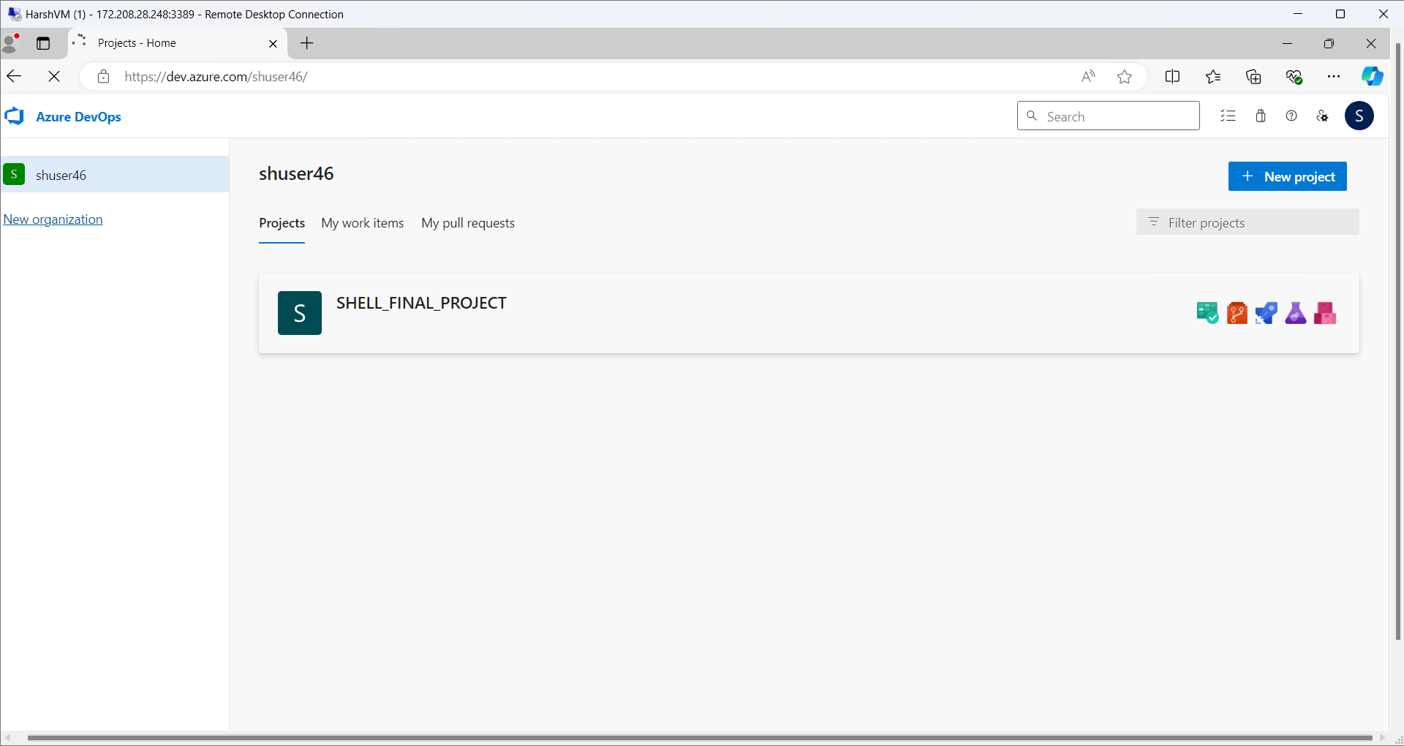

1. Here is the final project for DevOPs

Website (OrangeHRM) : “https://opensourcedemo.orangehrmlive.com/web/index.php/auth/login”

Objective: To test the concepts of SDLC, Agile, Software Testing, DBMS and CI/CD pipeline.

Task Instructions The below activity must be performed individually.

Follow the below instructions for the OrangeHRM website -

**USER STORY 1: Employee Management**

As an HR administrator, I want to be able to add, edit, and delete employee records to manage the workforce efficiently.

**SDLC Tasks:**

* **Planning:** Define requirements for employee management features.
* **Designing:** Create design specifications for adding, editing, and deleting employee records.
* **Coding:** Implement the functionality to manage employee records.
* **Testing:** Verify that all functionalities work as intended.
* **Feedback:** Review and refine functionalities based on testing results.

**Testing Phase - Test Cases:**

**Positive Test Case 1: Add New Employee**

* + **Test Steps:**
    1. Navigate to the employee management page.
    2. Click the “Add” button.
    3. Fill in valid employee details (e.g., name, ID, department).
    4. Click “Save.”
  + **Test Data:** Name: John Doe, ID: E12345, Department: HR
  + **Expected Result:** Employee is added successfully, and a confirmation message is displayed.
  + **Actual Result:** Employee John Doe was added successfully.
  + **Status:** Pass

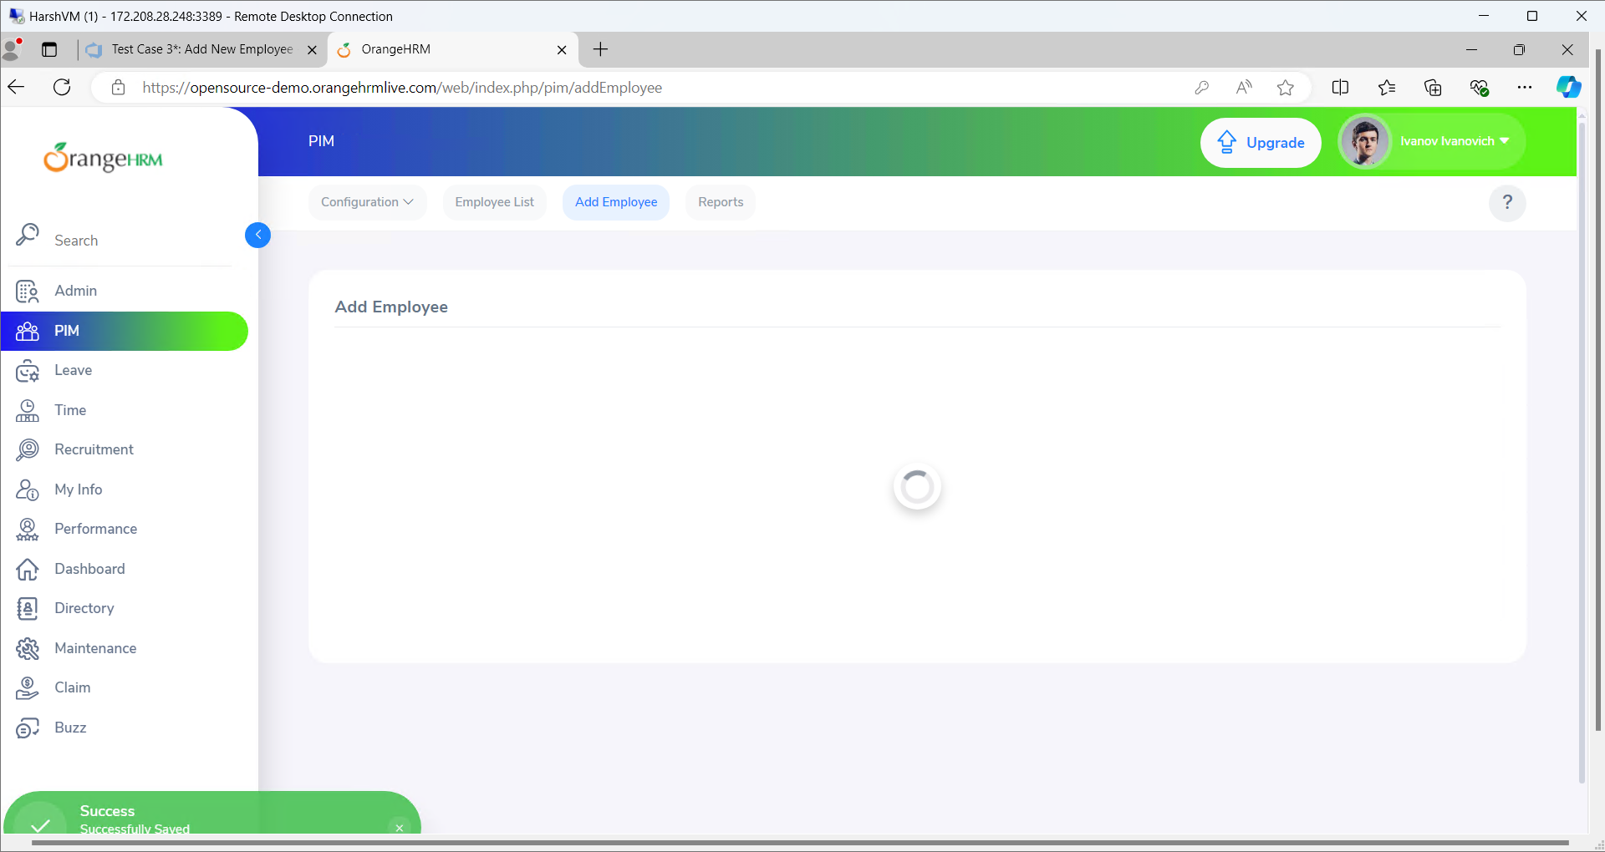

**Positive Test Case 2: Edit Employee Details**

* **Test Steps:**
  1. Navigate to the employee list page.
  2. Select an employee to edit.
  3. Update the employee details.
  4. Click “Save.”
* **Test Data:** New Department: IT
* **Expected Result:** Employee details are updated successfully, and the changes are reflected in the employee list.
* **Actual Result:** Employee details updated to IT department successfully.
* **Status:** Pass

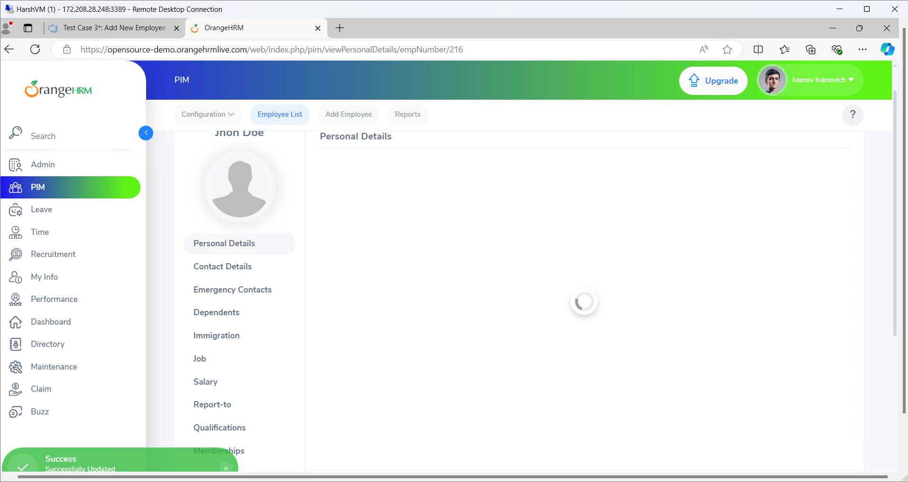

**Positive Test Case 3: Delete Employee Record**

* **Test Steps:**
  1. Navigate to the employee list.
  2. Select an employee to delete.
  3. Click “Delete” and confirm the action.
* **Test Data:** Employee ID: E54321
* **Expected Result:** Employee record is deleted successfully.
* **Actual Result:** [To be filled after testing] (e.g., "Employee E54321 was deleted successfully.")
* **Status:** [Pass/Fail] (e.g., "Pass")

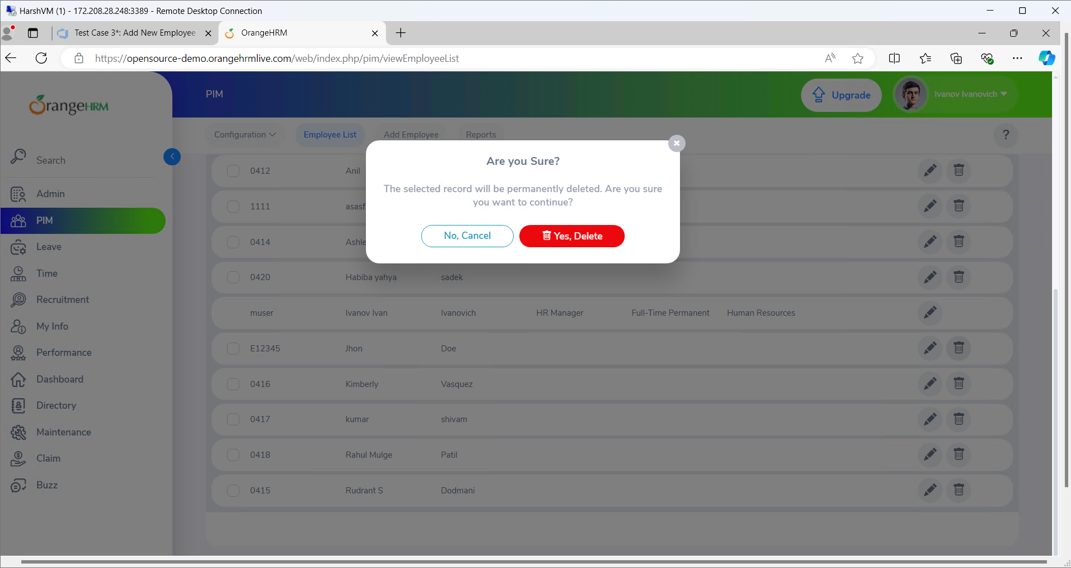

**Negative Test Case 1: Add Duplicate Employee**

* **Test Steps:**
  1. Navigate to the employee management page.
  2. Click the “Add” button.
  3. Enter details for an existing employee.
  4. Click “Save.”
* **Test Data:** Existing Employee ID: E12345
* **Expected Result:** Error message indicating that the employee already exists.
* **Actual Result:** Error message displayed: Employee already exists.
* **Status:** Pass

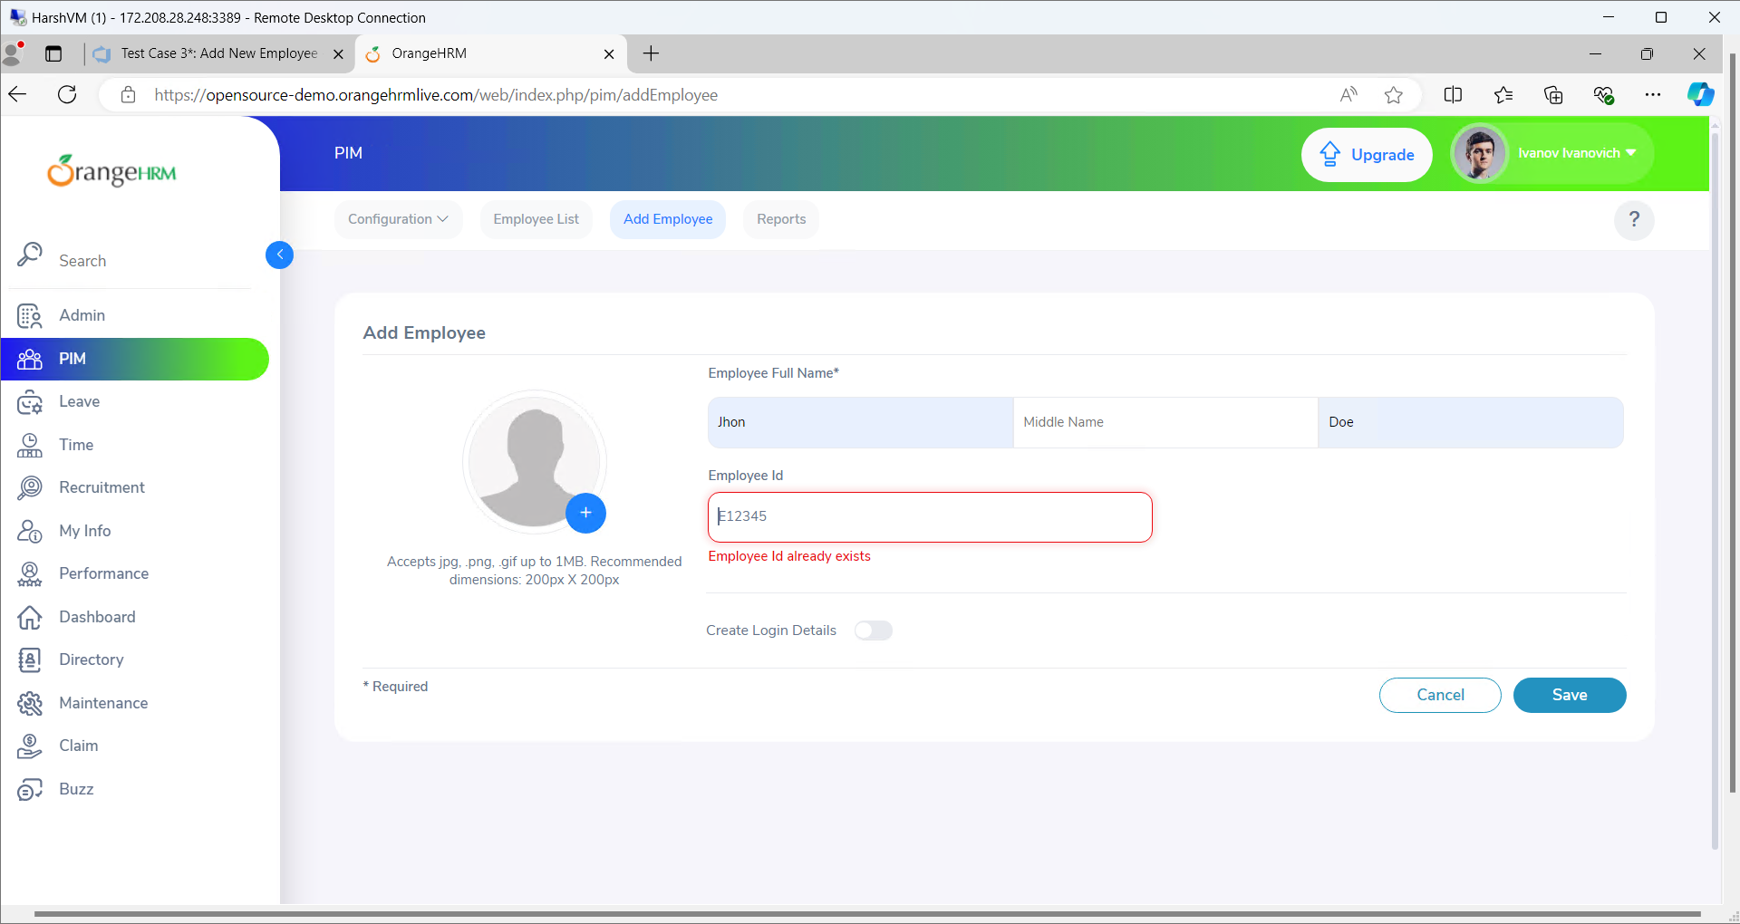

**Negative Test Case 2: Save Employee with Invalid Data**

* **Test Steps:**
  1. Navigate to the employee management page.
  2. Click the “Add” button.
  3. Enter invalid data (e.g., blank fields).
  4. Click “Save.”
* **Test Data:** Blank Employee ID
* **Expected Result:** Error message indicating that required fields are missing.
* **Actual Result:** NO error file
* **Status:** FAIL

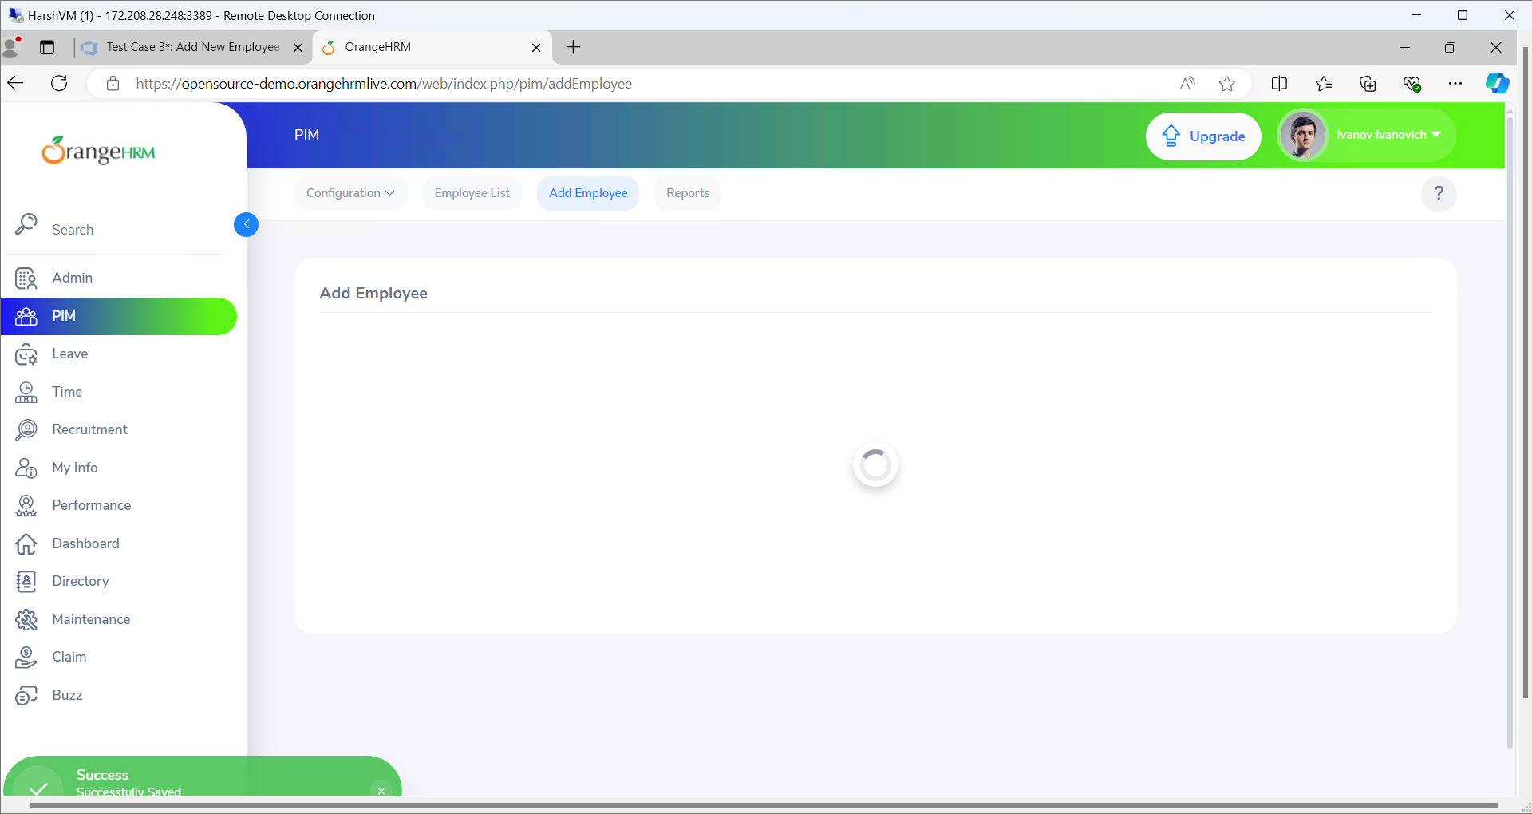

**Bug 1:** No error while saving without employee id

**Bug 2:** Save button unresponsive when required fields are empty.

**User Story 2: Leave Request Management**

*Description:* As an employee, I need to request leave online and view my leave history to manage my time off effectively.

**SDLC Tasks:**

* **Planning:** Define requirements for leave request submission and history retrieval.
* **Designing:** Create designs for leave request forms and history pages.
* **Coding:** Implement leave request submission and history functionalities.
* **Testing:** Verify the functionality of leave requests and history.
* **Feedback:** Gather feedback from users and refine features.

**Testing Phase - Test Cases:**

1. **Positive Test Case 1: Submit Leave Request**
   * **Test Steps:**
     1. Navigate to the leave request page.
     2. Enter valid leave details.
     3. Click “Submit.”
   * **Test Data:** Leave Type: Vacation, Start Date: 2024-10-01, End Date: 2024-10-05
   * **Expected Result:** Leave request is submitted successfully with a confirmation message.
   * **Actual Result:** Leave request for Vacation from 2024-10-01 to 2024-10-05 submitted successfully.
   * **Status:** Pass
2. **Positive Test Case 2: View Leave History**
   * **Test Steps:**
     1. Navigate to the leave history page.
     2. Verify that past leave requests are listed.
   * **Test Data:** Leave history data.
   * **Expected Result:** Leave history displays all previous leave requests correctly.
   * **Actual Result:** [To be filled after testing] (e.g., "Leave history displayed previous requests accurately.")
   * **Status:** [Pass/Fail] (e.g., "Pass")
3. **Positive Test Case 3: Cancel Leave Request**
   * **Test Steps:**
     1. Navigate to the leave request history page.
     2. Select a leave request to cancel.
     3. Click “Cancel” and confirm the action.
   * **Test Data:** Leave Request ID: L12345
   * **Expected Result:** Leave request is canceled successfully, and the status is updated.
   * **Actual Result:** [To be filled after testing] (e.g., "Leave request L12345 canceled successfully.")
   * **Status:** [Pass/Fail] (e.g., "Pass")
4. **Negative Test Case 1: Submit Leave Request with Invalid Dates**
   * **Test Steps:**
     1. Navigate to the leave request page.
     2. Enter an end date before the start date.
     3. Click “Submit.”
   * **Test Data:** Start Date: 2024-10-05, End Date: 2024-10-01
   * **Expected Result:** Error message indicating invalid date range.
   * **Actual Result:** [To be filled after testing] (e.g., "Error message: End date cannot be before start date.")
   * **Status:** [Pass/Fail] (e.g., "Pass")
5. **Negative Test Case 2: Leave Request Submission with Empty Fields**
   * **Test Steps:**
     1. Navigate to the leave request page.
     2. Leave required fields empty.
     3. Click “Submit.”
   * **Test Data:** Empty required fields.
   * **Expected Result:** Error message indicating that required fields are missing.
   * **Actual Result:** [To be filled after testing] (e.g., "Error message: Required fields must be filled.")
   * **Status:** [Pass/Fail] (e.g., "Pass")

**Bugs:**

1. **Bug 1:** Error message for invalid dates is not displayed.
2. **Bug 2:** Leave request form submission fails without proper validation feedback.

**User Story 3: Performance Review Management**

*Description:* As a manager, I need to create and review performance evaluations for team members to assess their progress and provide feedback.

**SDLC Tasks:**

* **Planning:** Identify performance review requirements and evaluation criteria.
* **Designing:** Develop design for performance review forms and review interfaces.
* **Coding:** Implement performance review creation and viewing functionalities.
* **Testing:** Validate the performance review creation and retrieval process.
* **Feedback:** Gather feedback and make necessary adjustments.

**Testing Phase - Test Cases:**

1. **Positive Test Case 1: Create Performance Review**
   * **Test Steps:**
     1. Navigate to the performance review section.
     2. Enter performance review details for an employee.
     3. Click “Save.”
   * **Test Data:** Employee: Bob Johnson, Review: Excellent performance.
   * **Expected Result:** Performance review is created successfully with a confirmation message.
   * **Actual Result:** [To be filled after testing] (e.g., "Performance review for Bob Johnson created successfully.")
   * **Status:** [Pass/Fail] (e.g., "Pass")
2. **Positive Test Case 2: View Performance Review**
   * **Test Steps:**
     1. Navigate to the performance review list.
     2. Select a performance review to view.
   * **Test Data:** Employee: Alice Smith
   * **Expected Result:** Performance review details for the selected employee are displayed correctly.
   * **Actual Result:** [To be filled after testing] (e.g., "Performance review for Alice Smith displayed correctly.")
   * **Status:** [Pass/Fail] (e.g., "Pass")
3. **Positive Test Case 3: Update Performance Review**
   * **Test Steps:**
     1. Navigate to the performance review section.
     2. Select a performance review to edit.
     3. Modify review details.
     4. Click “Save.”
   * **Test Data:** New Review: Needs improvement.
   * **Expected Result:** Performance review is updated successfully.
   * **Actual Result:** [To be filled after testing] (e.g., "Performance review updated successfully.")
   * **Status:** [Pass/Fail] (e.g., "Pass")
4. **Negative Test Case 1: Create Performance Review for Nonexistent Employee**
   * **Test Steps:**
     1. Navigate to the performance review section.
     2. Enter details for a nonexistent employee.
     3. Click “Save.”
   * **Test Data:** Employee: Nonexistent Employee
   * **Expected Result:** Error message indicating that the employee does not exist.
   * **Actual Result:** [To be filled after testing] (e.g., "Error message: Employee does not exist.")
   * **Status:** [Pass/Fail] (e.g., "Pass")
5. **Negative Test Case 2: Update Performance Review with Invalid Data**
   * **Test Steps:**
     1. Navigate to the performance review section.
     2. Attempt to update a performance review with invalid data (e.g., empty review field).
     3. Click “Save.”
   * **Test Data:** Empty Review Field
   * **Expected Result:** Error message indicating invalid data.
   * **Actual Result:** [To be filled after testing] (e.g., "Error message: Review field cannot be empty.")
   * **Status:** [Pass/Fail] (e.g., "Pass")

**Bugs:**

1. **Bug 1:** Error message for nonexistent employee not displayed.
2. **Bug 2:** Performance review update fails without validation.

**User Story 4: Reporting and Analytics**

*Description:* As a report administrator, I need to generate and export reports to analyze employee performance, leave trends, and other key metrics.

**SDLC Tasks:**

* **Planning:** Define reporting requirements and data sources.
* **Designing:** Create report templates and export options.
* **Coding:** Develop report generation and export functionalities.
* **Testing:** Test report generation and export features.
* **Feedback:** Review feedback and refine reporting functionalities.

**Testing Phase - Test Cases:**

1. **Positive Test Case 1: Generate Performance Report**
   * **Test Steps:**
     1. Navigate to the reporting section.
     2. Select “Performance Report” and apply filters.
     3. Click “Generate.”
   * **Test Data:** Report Type: Performance, Filters: Department: IT
   * **Expected Result:** Performance report is generated successfully with applied filters.
   * **Actual Result:** [To be filled after testing] (e.g., "Performance report generated successfully.")
   * **Status:** [Pass/Fail] (e.g., "Pass")
2. **Positive Test Case 2: Export Report to Excel**
   * **Test Steps:**
     1. Generate a report.
     2. Click “Export” and choose Excel format.
   * **Test Data:** Report in Excel format.
   * **Expected Result:** Report is exported successfully to Excel format.
   * **Actual Result:** [To be filled after testing] (e.g., "Report exported to Excel format successfully.")
   * **Status:** [Pass/Fail] (e.g., "Pass")
3. **Positive Test Case 3: Apply Filters to Report**
   * **Test Steps:**
     1. Navigate to the reporting section.
     2. Generate a report and apply different filters.
   * **Test Data:** Filters: Date Range: 2024-01-01 to 2024-09-30
   * **Expected Result:** Report data is filtered according to the applied filters.
   * **Actual Result:** [To be filled after testing] (e.g., "Report filtered successfully according to the specified date range.")
   * **Status:** [Pass/Fail] (e.g., "Pass")
4. **Negative Test Case 1: Generate Report with No Filters**
   * **Test Steps:**
     1. Navigate to the reporting section.
     2. Attempt to generate a report without applying any filters.
   * **Test Data:** No filters applied.
   * **Expected Result:** Error message indicating that filters are required.
   * **Actual Result:** [To be filled after testing] (e.g., "Error message: Filters are required to generate the report.")
   * **Status:** [Pass/Fail] (e.g., "Pass")
5. **Negative Test Case 2: Export Report When Export Function is Disabled**
   * **Test Steps:**
     1. Generate a report.
     2. Attempt to export the report while the export function is disabled.
   * **Test Data:** Generated report.
   * **Expected Result:** Error message indicating that the export function is disabled.
   * **Actual Result:** [To be filled after testing] (e.g., "Error message: Export function is currently disabled.")
   * **Status:** [Pass/Fail] (e.g., "Pass")

**Bugs:**

1. **Bug 1:** Export function for reports is not available despite being enabled.
2. **Bug 2:** Report generation fails with incorrect filter application.

**User Story 5: System Security and Access Control**

*Description:* As a system administrator, I need to ensure that user access and security controls are correctly implemented to protect sensitive data.

**SDLC Tasks:**

* **Planning:** Define security requirements and access control mechanisms.
* **Designing:** Design security and access control features.
* **Coding:** Implement security controls and user access restrictions.
* **Testing:** Test security features and access control.
* **Feedback:** Collect feedback and make necessary adjustments.

**Testing Phase - Test Cases:**

1. **Positive Test Case 1: Access Control for Admin User**
   * **Test Steps:**
     1. Log in as an Admin user.
     2. Navigate to admin-only sections.
   * **Test Data:** Admin credentials.
   * **Expected Result:** Admin user should have access to admin-only sections.
   * **Actual Result:** [To be filled after testing] (e.g., "Admin user accessed all admin sections successfully.")
   * **Status:** [Pass/Fail] (e.g., "Pass")
2. **Positive Test Case 2: Restrict Access for Non-Admin User**
   * **Test Steps:**
     1. Log in as a non-admin user.
     2. Attempt to access admin-only sections.
   * **Test Data:** Non-admin credentials.
   * **Expected Result:** Non-admin user should be restricted from accessing admin-only sections.
   * **Actual Result:** [To be filled after testing] (e.g., "Non-admin user was restricted from admin sections successfully.")
   * **Status:** [Pass/Fail] (e.g., "Pass")
3. **Positive Test Case 3: Password Change Functionality**
   * **Test Steps:**
     1. Log in as a user.
     2. Navigate to the profile settings.
     3. Change the password.
     4. Log out and log in with the new password.
   * **Test Data:** New Password: NewPass123!
   * **Expected Result:** Password is changed successfully and user can log in with the new password.
   * **Actual Result:** [To be filled after testing] (e.g., "Password changed successfully and login with new password was successful.")
   * **Status:** [Pass/Fail] (e.g., "Pass")
4. **Negative Test Case 1: Access Admin Section Without Proper Permissions**
   * **Test Steps:**
     1. Log in as a user without admin permissions.
     2. Attempt to access admin-only sections.
   * **Test Data:** Non-admin credentials.
   * **Expected Result:** Access should be denied with an appropriate error message.
   * **Actual Result:** [To be filled after testing] (e.g., "Access denied message displayed.")
   * **Status:** [Pass/Fail] (e.g., "Pass")
5. **Negative Test Case 2: Login with Incorrect Credentials**
   * **Test Steps:**
     1. Navigate to the login page.
     2. Enter incorrect credentials.
     3. Click “Login.”
   * **Test Data:** Username: invaliduser, Password: invalidpass
   * **Expected Result:** Error message indicating invalid credentials.
   * **Actual Result:** [To be filled after testing] (e.g., "Error message: Invalid credentials.")
   * **Status:** [Pass/Fail] (e.g., "Pass")

**Bugs:**

1. **Bug 1:** Error message for invalid credentials is not displayed.
2. **Bug 2:** Restricted access to admin sections is bypassed due to permissions error.

**5. Execute All the Test Cases Manually**

**Steps to Execute:**

1. Log in to the application with the provided credentials.
2. Navigate to the relevant sections based on the test cases.
3. Perform the test steps as detailed in each test case.
4. Record the actual results and compare them with the expected results.
5. Mark each test case as pass or fail based on the results.

**6. Create a Defect Report for Each Failed or Blocked Test Case**

**Example Defect Report:**

* **Defect ID:** DEF001
* **Summary:** Error message for duplicate ID not displayed.
* **Description:** When attempting to add an employee with an existing ID, no error message is shown.
* **Steps to Reproduce:**
  1. Navigate to the employee management page.
  2. Enter an existing ID.
  3. Click “Save.”
* **Expected Result:** Error message indicating the ID already exists.
* **Actual Result:** No error message displayed.
* **Severity:** Major
* **Status:** Open
* **Assigned To:** Development Team

This guide should help you effectively manage the sprint, user stories, and testing processes for the OrangeHRM application.

**Implementing the CI/CD Pipeline using GitHub Actions**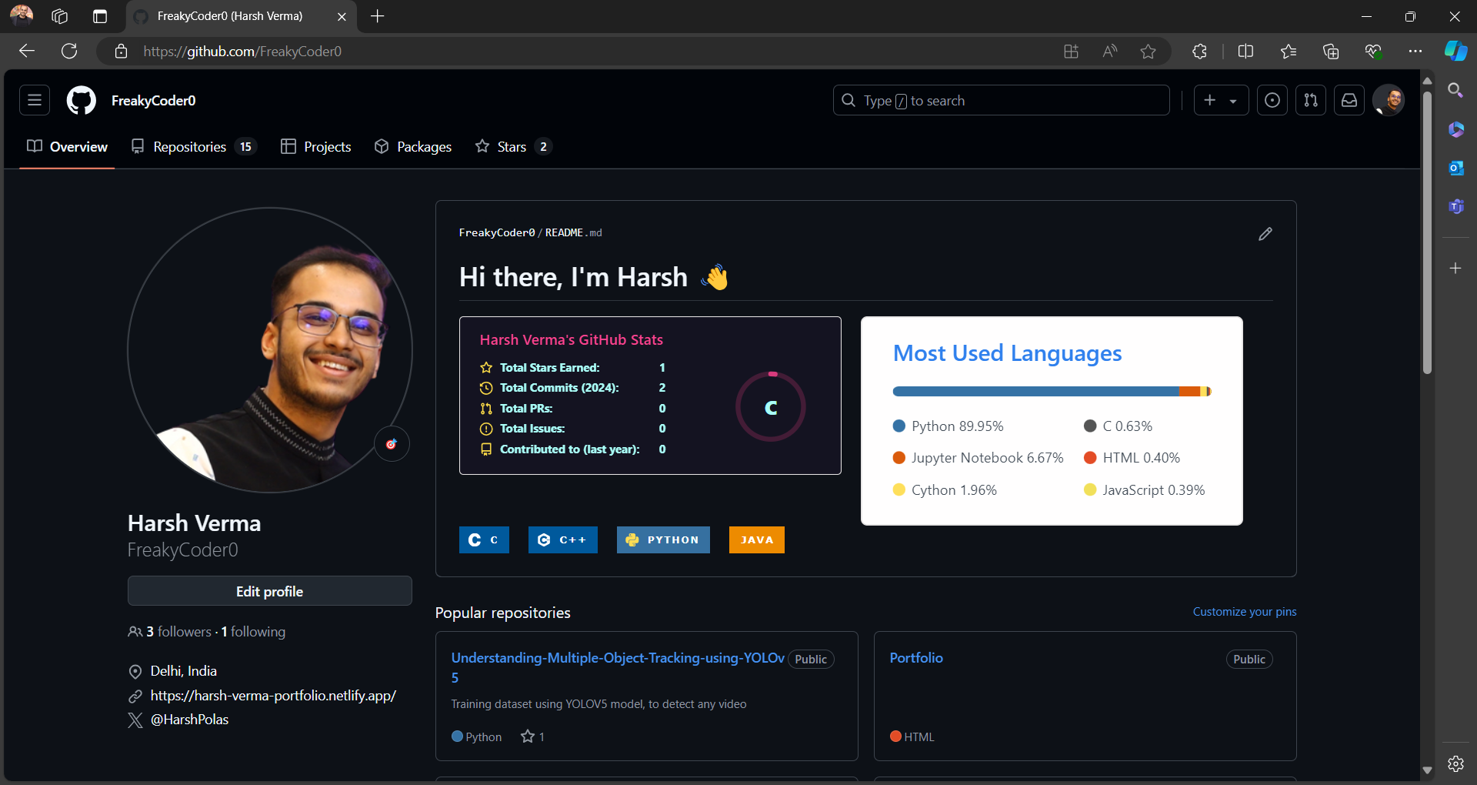

1. Open github

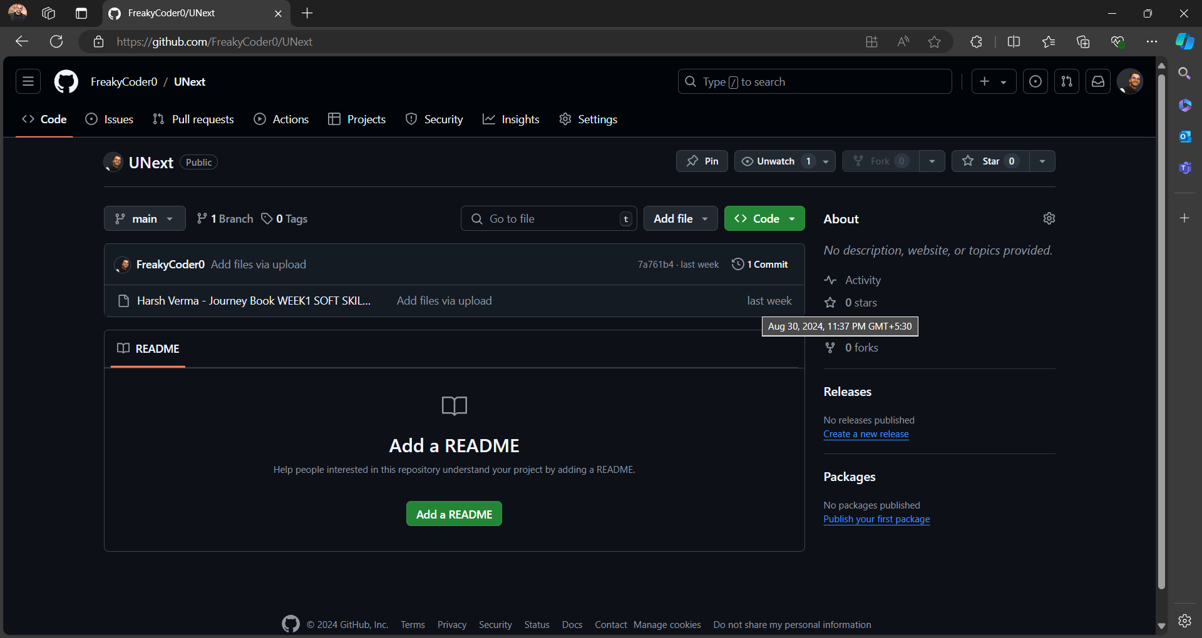

1. Created a repo name “UNext”

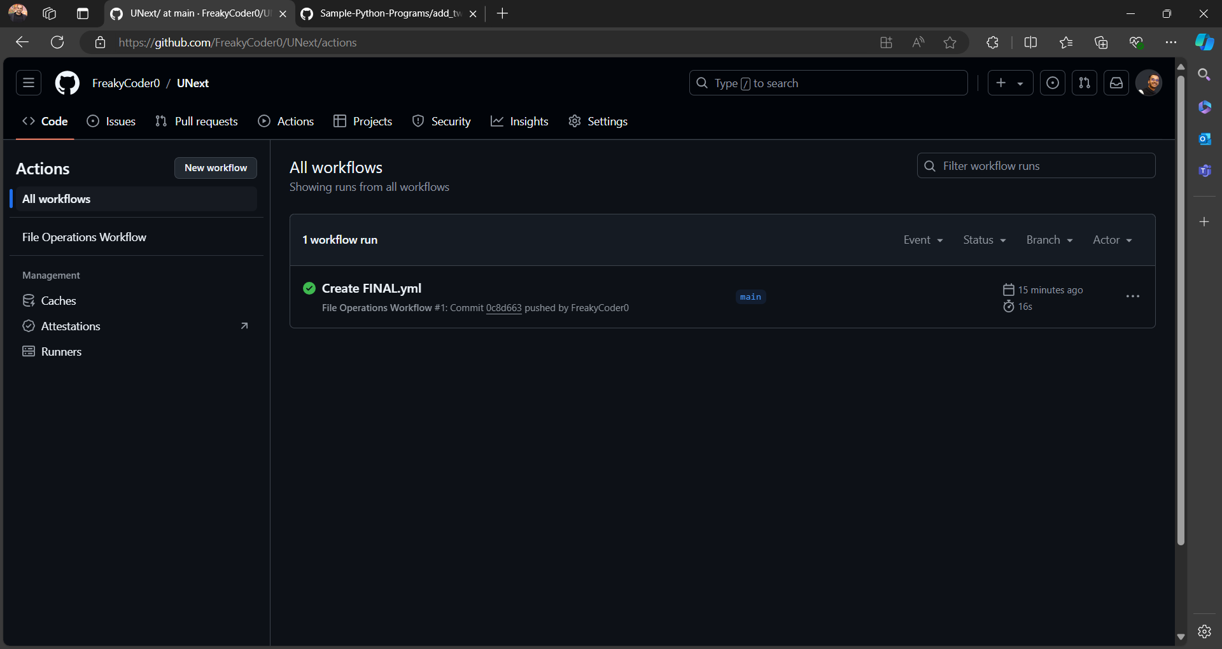

1. Now go to actions tab.

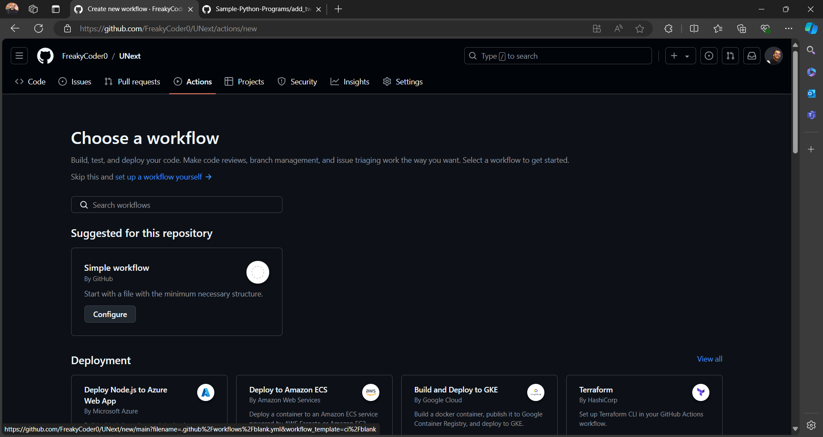

1. Choose new workflow

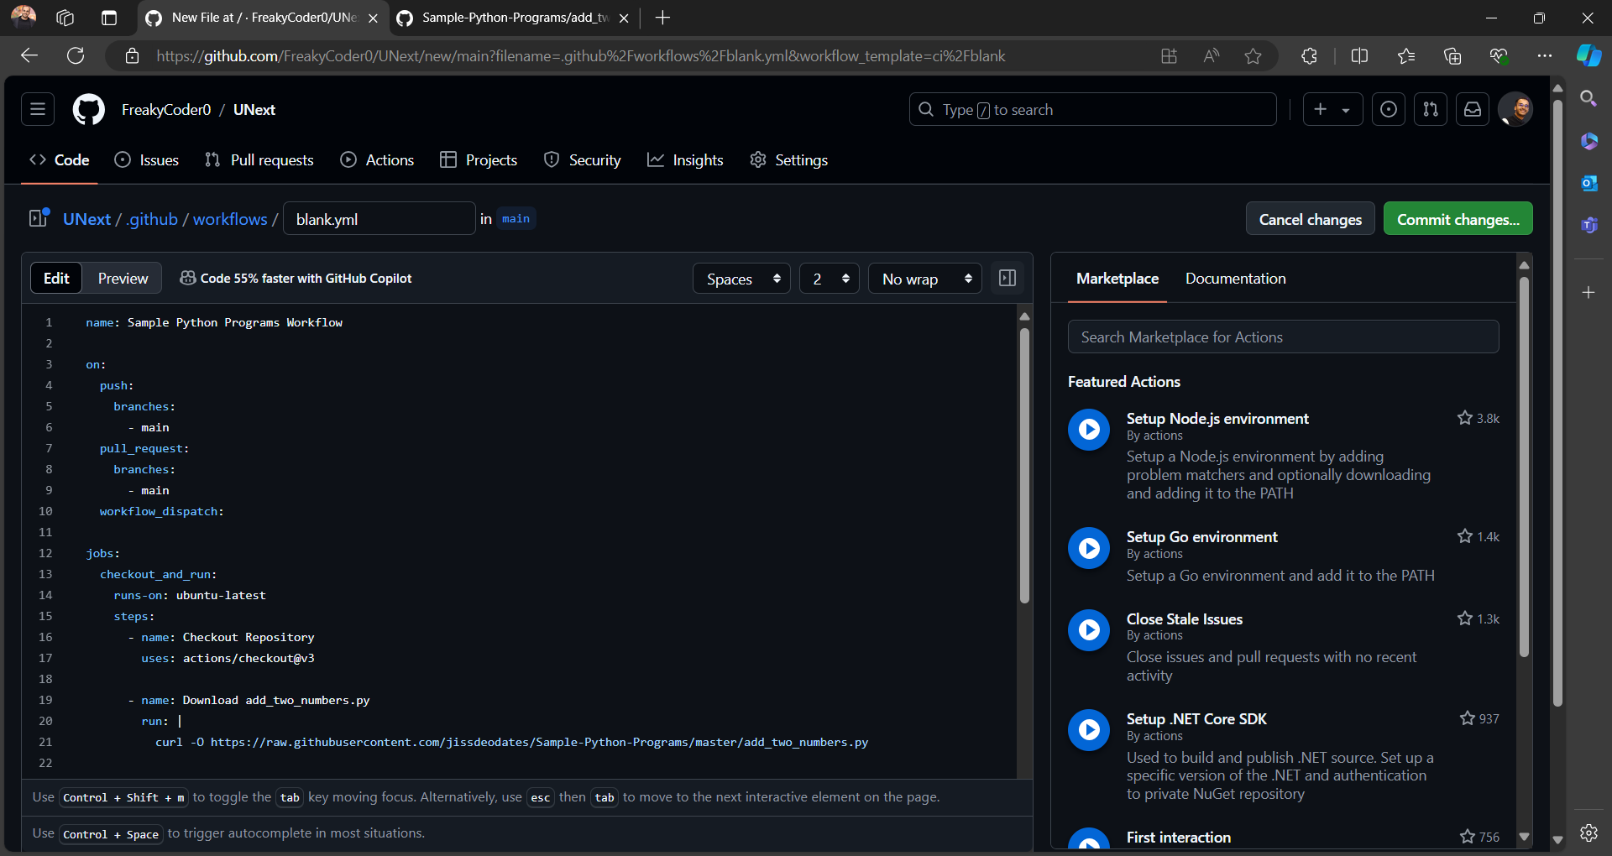

1. Now write the code for cloning and performing the action in the code of add_two_numbers.py “[Sample-Python-Programs/add_two_numbers.py at master · jissdeodates/Sample-Python-Programs (github.com)](https://github.com/jissdeodates/Sample-Python-Programs/blob/master/add_two_numbers.py)”

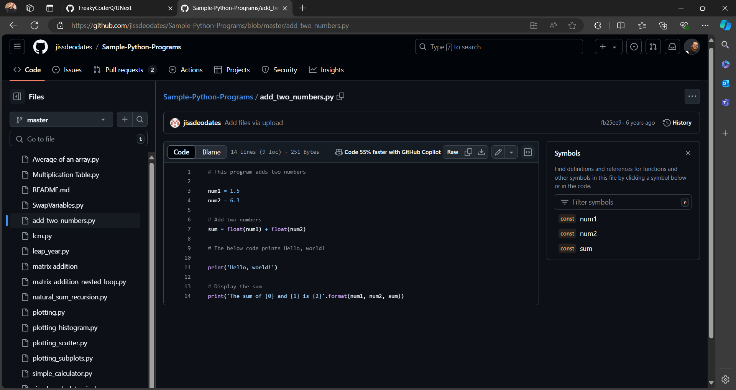

1. This is the file that I have cloned.

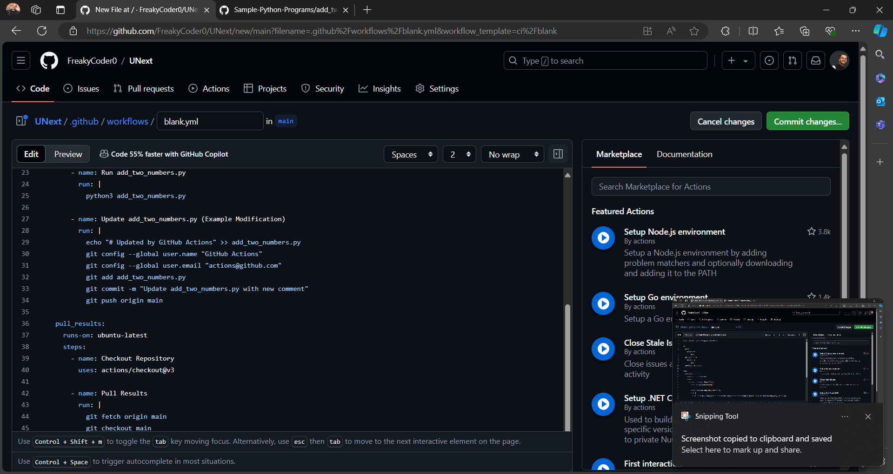

1. This is the continuity of the code.

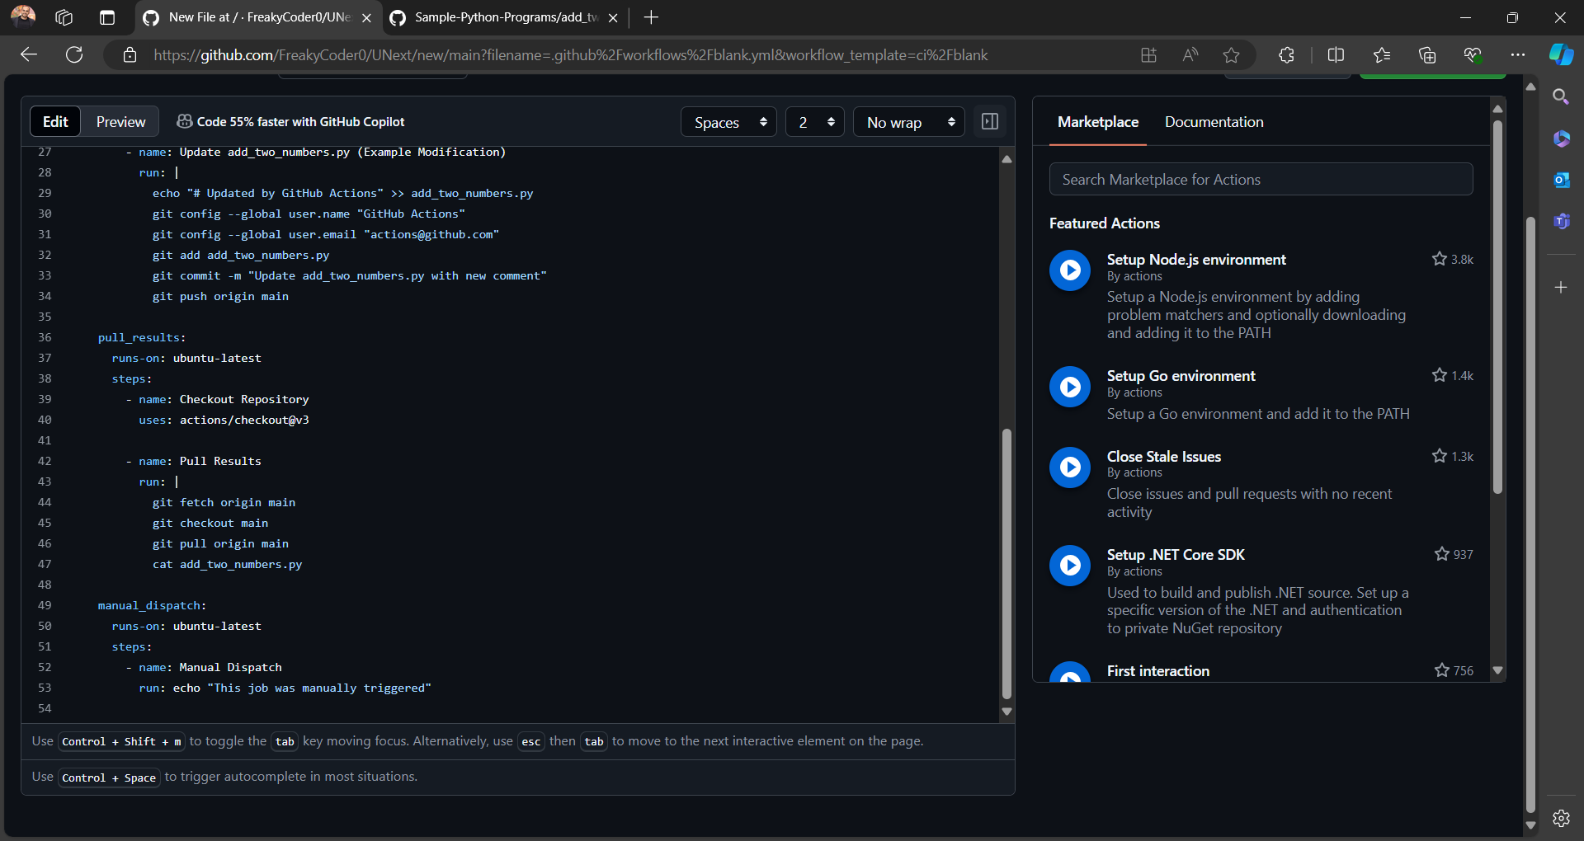

1. Continued.

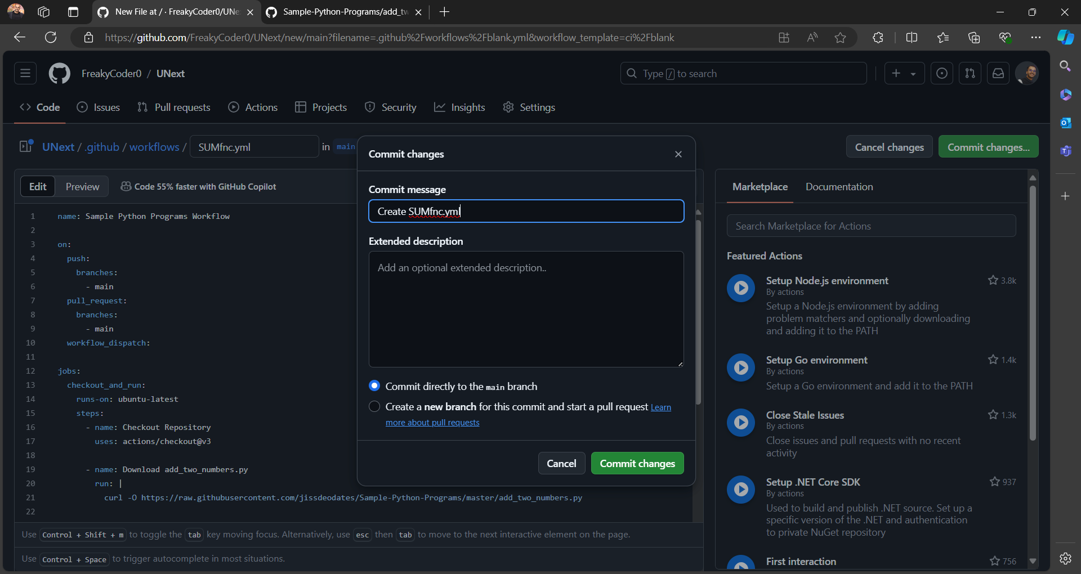

1. Commit changes.

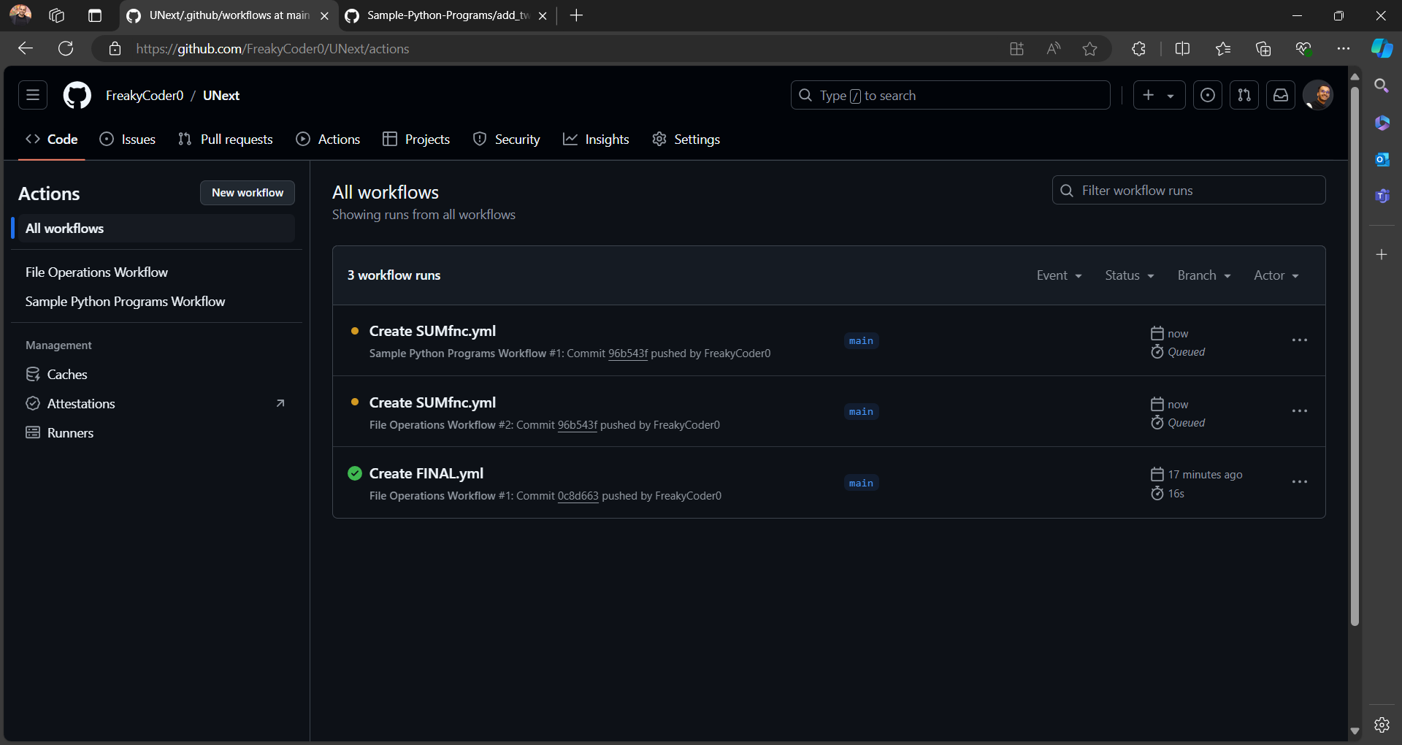

1. Waiting for committing the changes .

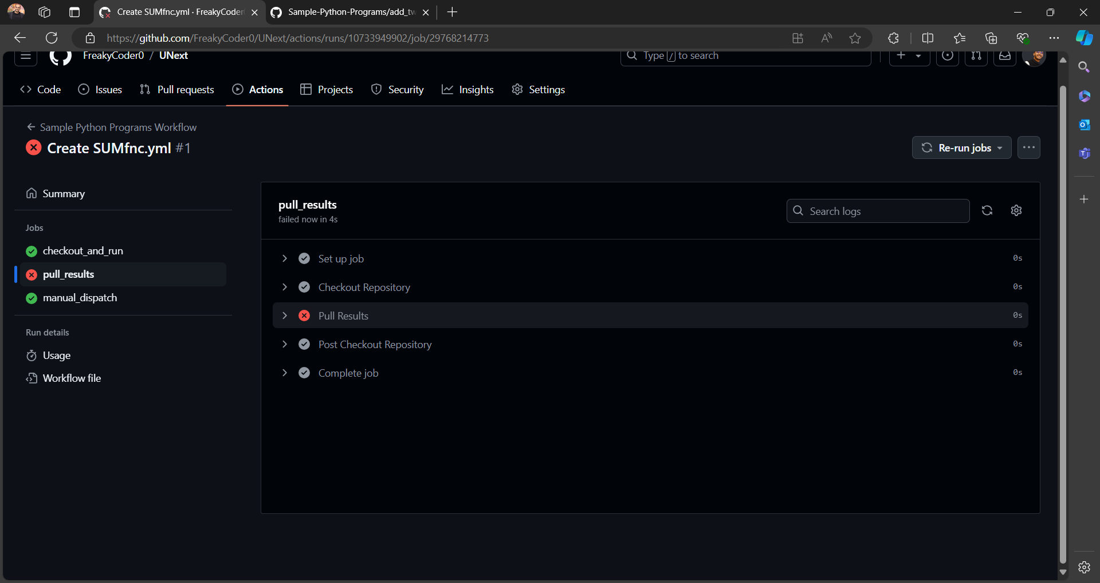

1. The pull request failed first.

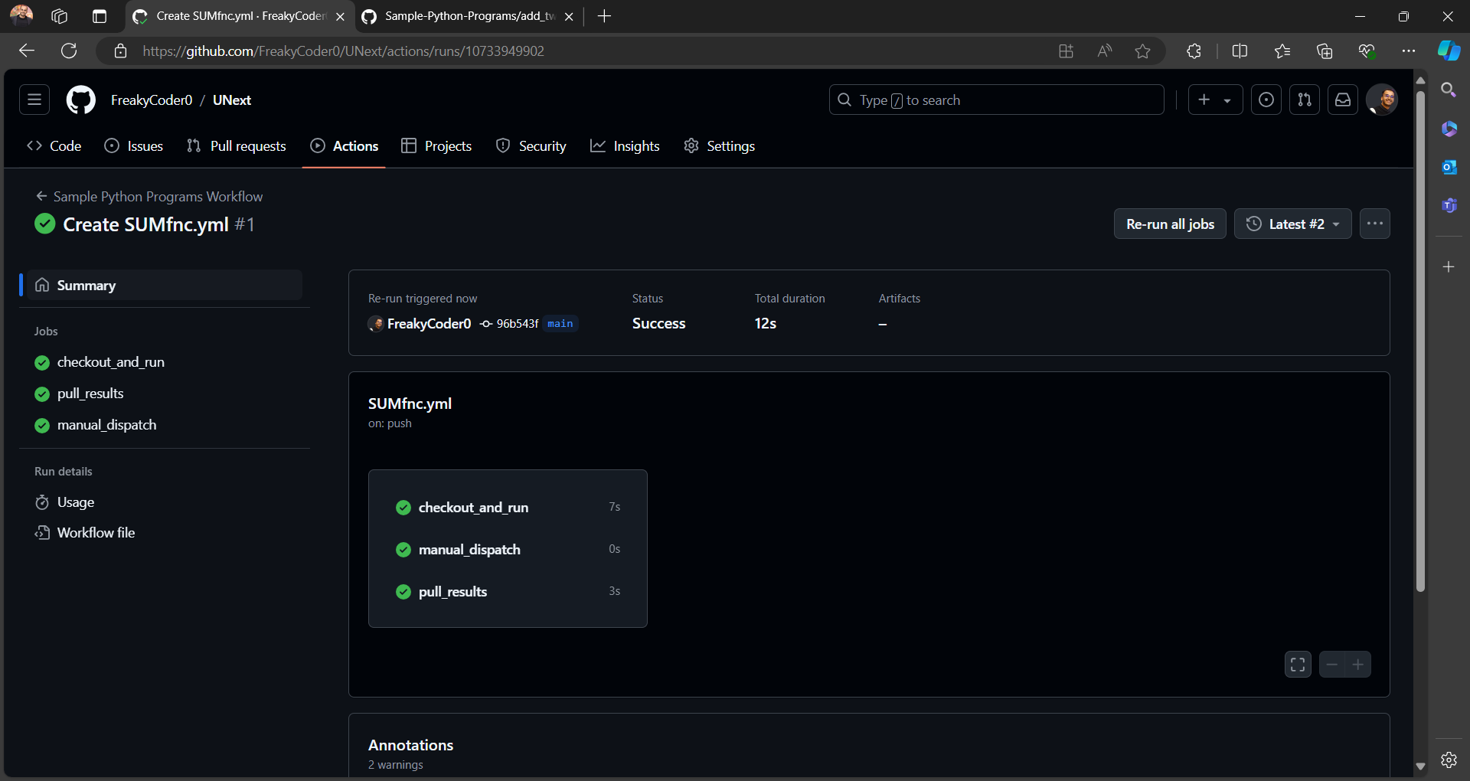

1. Then performed the operation of action again to perform the addition.

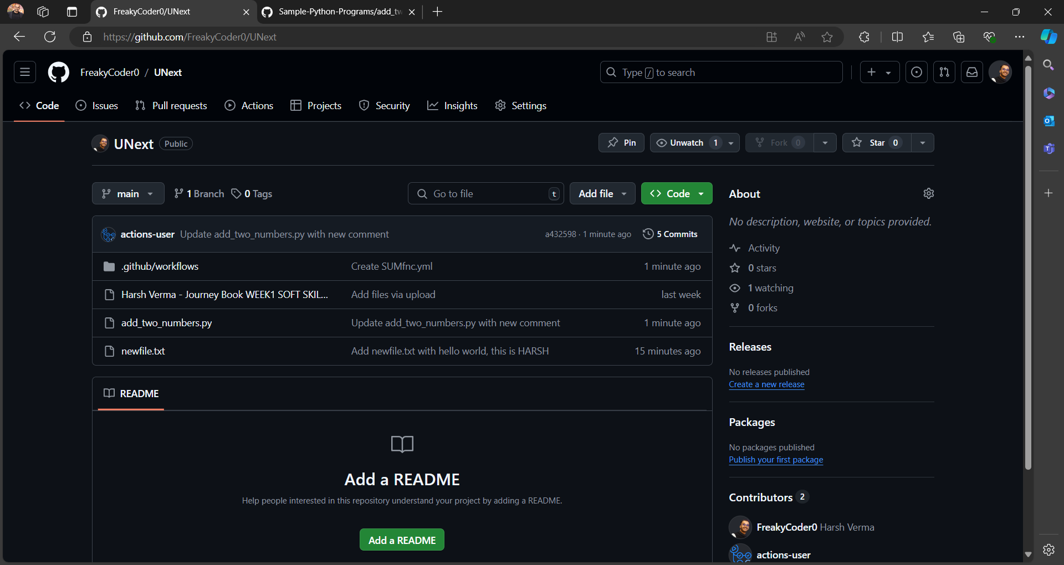13. Finally the action is performed successfully.